Instructions for Angry Bird Structure
Part 1: Create
- Create a multi-story structure with a platform on the top story using only the materials provided. Design your structure however you think it will best stand when the forces of gravity, hurricane and earthquake are applied.
Each group will have the same building materials. These materials are:
- 1 cardboard base
- 30 craft sticks
- 7 straws
- 1 piece of construction paper
- 10 paper clips
- 3 arm lengths of masking tape (6 feet)

Examples: 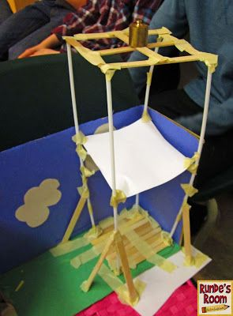 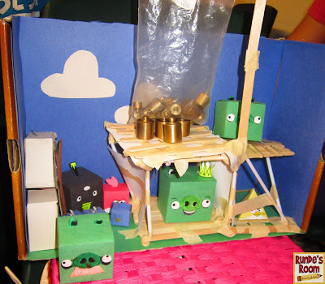
Optional measurement challenge: Make your structure at least 12 inches (30cm) high. Make the top platform 4 inches x 4 inches (10cm x 10cm). Rulers to be provided.
- Cut out the Angry Bird paper templates and assemble. These Angry Birds will sit in your structure when it is completed. Adding color is optional.

Part 2: Test
- Take your completed structure to the testing station. The docent there will test your structure to see if it stands up to the forces of nature.
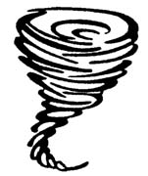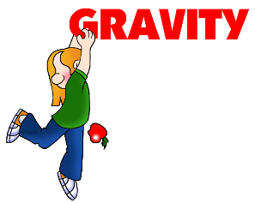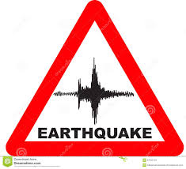

- After the testing is completed, politely ask for a catapult and a few plastic launching Angry Birds.
Part 3: Have fun
- Bombs away!!!! Practice launching the plastic Angry Birds at your structure with the paper Angry Birds. Your catapult uses potential and kinetic energy and when you launch your angry bird the forces of gravity pull it down.

A catapult works by the process of potential and kinetic energy. A catapult works because energy can be converted from one type to another and transferred from one object to another. When you prepare the catapult to launch, you add energy to it. This energy is stored in the launching device as potential, or stored, energy. The catapult you are about to make uses elastic potential energy stored in the binder clip and wooden sticks as you bend it. When you let go, this stored energy is released, converted into energy of motion and transferred to the missile (the launched object), which then flies through the air.

