Student Bouncy Ball Instructions

Experiment Procedure:
Start by taking two cups. With a marker label one cup Borax Solution and the other cup Ball Mixture.
In the cup labeled “Borax Solution”
- Pour 2 tablespoons (30ml) of warm water into the cup labeled Borax Solution. Then add 1/2 teaspoon of the borax powder into the cup. For a bouncier ball add 1 teaspoon of borax. Stir the solution to dissolve the borax.
In the cup labeled “Ball Mixture”
- Pour 1 tablespoon of glue into the cup. Add 4-5 drops of food coloring and stir.

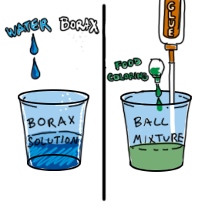
- Add 1/2 teaspoon of the borax solution from the cup labeled Borax Solution (the one you just made) and put it into the cup labeled Ball Mixture.
- Add 1 tablespoon of cornstarch to the glue mixture. Do not stir. Allow the ingredients to interact on their own for 15 seconds and then stir them together to fully mix. Use the second hands on the clock to watch the time.
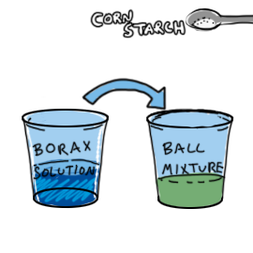
- Stir. Once the mixture becomes impossible to stir, take it out of the cup and start molding the ball with your hands. The ball will start out sticky and messy, but will solidify as you knead it. Once the ball is less sticky, continue rolling between your hands until it is smooth and round!
- Set it aside and allow it to rest on the table for 5 minutes before bouncing it.
- While waiting for your ball to dry clean up your materials and table area.
- Does it bounce? Compare it with another students who may have had different results. Does it feel the same? Do they bounce the same height? Use a ruler to measure their height. Are they the same size (diameter)?
- Put your completed bouncy ball in a Zip-lock bag and write your name on the bag. You may take your ball home.
