Design a Space Suit for Future Travel to Mars
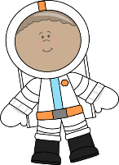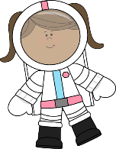
GOAL:
The environment on Mars is different than that of the Moon. Astronauts who travel to Mars in the future need your help designing a new space suit.
CONDITIONS ON MARS:
Length of Day on Mars: 24 hours, 37 minutes
Surface gravity compared to Earth: 0.38 (If you weigh 100 pounds on Earth you will weigh 38 pounds on Mars)
Main gas on Mars: Carbon dioxide
How long to get to Mars: At least six months

Describe or list what makes your Mars Space Suit different from other designs. What special features does it have?
____________________________________________________________________
____________________________________________________________________
____________________________________________________________________
____________________________________________________________________
____________________________________________________________________
____________________________________________________________________
____________________________________________________________________
____________________________________________________________________
My Space Suit:
Draw your space suit below.

MY SPACE SUIT DESIGN:

