***2nd Grade – Forces & Motion & Friction***

**Objective:**

Students will learn about potential,kinetic energy and centripetal force through three hands-on experiments.

|  |  |  |
| --- | --- | --- |
| |  | | --- | | [**PS2.A: Forces and Motion**](http://www.nap.edu/openbook.php?record_id=13165&page=114)   * [Newton’s second law accurately predicts changes in the motion of macroscopic objects. (HS-PS2-1)](http://www.nap.edu/openbook.php?record_id=13165&page=114) * [Momentum is defined for a particular frame of reference; it is the mass times the velocity of the object. (HS-PS2-2)](http://www.nap.edu/openbook.php?record_id=13165&page=114) * [If a system interacts with objects outside itself, the total momentum of the system can change; however, any such change is balanced by changes in the momentum of objects outside the system. (HS-PS2-2),(HS-PS2-3)](http://www.nap.edu/openbook.php?record_id=13165&page=114)   [**PS2.B: Types of Interactions**](http://www.nap.edu/openbook.php?record_id=13165&page=116)   * [Newton’s law of universal gravitation and Coulomb’s law provide the mathematical models to describe and predict the effects of gravitational and electrostatic forces between distant objects. (HS-PS2-4)](http://www.nap.edu/openbook.php?record_id=13165&page=116) * [Forces at a distance are explained by fields (gravitational, electric, and magnetic) permeating space that can transfer energy through space. Magnets or electric currents cause magnetic fields; electric charges or changing magnetic fields cause electric fields. (HS-PS2-4),(HS-PS2-5)](http://www.nap.edu/openbook.php?record_id=13165&page=116) | |  |

**Docent Lab Guidelines:**

1. Docent(s) should plan to arrive early to set up before the class arrives.
2. Reserve the science room on the Science Lab Master Schedule. Please make sure you add 30 minutes of set up time and about 30 minutes of clean up time to the overall class time.
3. This lab works best if there is at least 3 docents (1 per table group).
4. Safety glasses are not required. But aprons should be worn to protect clothes from dye.
5. Give a brief 5-10 minute overview of what force, friction and motion are and how they relate to our daily lives. You can also opt to play a short video instead of speaking. These are listed below.
6. There are three experiments. Students will rotate between the three stations. Keep track of time and notify the students when it is time to switch.
7. Allow enough time at the end for students to wash up afterwards if needed.
8. The last 5-10 minutes of class review the student’s observation as a group.

**Forces & Motion Facts from** *Science Trek*

**(For Docent’s Reference Only)**

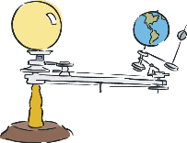

[Motion](http://idahoptv.org/sciencetrek/topics/force_and_motion/glossary.cfm#motion) makes the world go 'round. Motion makes the moon go 'round too. In fact, motion makes lots of things go. When we think of motion we often think of cars, bicycles, kids running, basketballs bouncing and airplanes flying. But motion is so much more. Motion is important to our lives and impacts so many things that we do. Motion is the changing of position or location. But motion requires a force to cause that change. Let's learn about force and motion and the effects of these physical laws in our world.

**What is Force?**

Force is just a fancy word for pushing or pulling. If I push on something or pull on it, then I am applying a force to it. Force makes things move or, more accurately, makes things change their motion. Two natural forces that we have experienced are the force of [gravity](http://idahoptv.org/sciencetrek/topics/force_and_motion/glossary.cfm#gravity) and [magnetic forces](http://idahoptv.org/sciencetrek/topics/force_and_motion/glossary.cfm#magnetic%20force) magnetic forces.

These two forces act at a distance and do not require direct contact between the objects to function. Gravity produces a force that pulls objects towards each other, like a person towards the ground. It is the force that keeps the Earth revolving around the sun and it's what pulls you toward the ground when you trip.

**Types Of Contact Forces**

There are 6 kinds of forces which act on objects when they come into contact with one another. Remember, a force is either a push or pull. The 6 are:

* normal force
* applied force
* frictional force
* tension force
* spring force
* resisting force

Let's investigate how these forces can be seen in our lives.

**Normal Force**

A book resting on a table has the force of gravity pulling it toward the Earth. But the book is not moving or accelerating, so there must be [opposing forces**opposing forces:** forces that work against each other](http://idahoptv.org/sciencetrek/topics/force_and_motion/glossary.cfm#opposing%20forces)  acting on the book. This force is caused by the table and is known as the normal force.

**Applied Force**

[Applied force](http://idahoptv.org/sciencetrek/topics/force_and_motion/glossary.cfm#applied%20force) refers to a force that is applied to an object such as when a person moves a piece of furniture across the room or pushes a button on the remote control. A force is applied.

**Frictional Force**

[Frictional force**frictional force:** the force caused by friction](http://idahoptv.org/sciencetrek/topics/force_and_motion/glossary.cfm#frictional%20force)  is the force caused by two surfaces that come into contact with each other. Friction can be helpful as in the friction that allows a person to walk across the ground without sliding or it can be destructive such as the friction of moving parts in a motor that rub together over long periods of time.

**Tension Force**

[Tension force](http://idahoptv.org/sciencetrek/topics/force_and_motion/glossary.cfm#tension%20force) is the force applied to a cable or wire that is anchored on opposite ends to opposing walls or other objects. This causes a force that pulls equally in both directions.

**Spring Force**

The [spring force](http://idahoptv.org/sciencetrek/topics/force_and_motion/glossary.cfm#spring%20force) is the force created by a compressed or stretched spring. Depending upon how the spring is attached, it can pull or push in order to create a force.

**Resisting Forces**

[Resisting force](http://idahoptv.org/sciencetrek/topics/force_and_motion/glossary.cfm#resisting%20force), like air resistance or friction, change motion. Whether the forces actually stop or slow something depends upon your point of view. Air friction makes a leaf travel along in the wind. When you pick up a pencil, it's friction with your fingers that gets the pencil in motion. In each case, the friction makes the two things (like the air and the leaf) move together.

**Videos on Forces & Motion:**

* 1. Forces and Motion (Kids educational video. This video explains Newton’s Laws of Motion, Run time 2 min. 50 sec.)

<http://ca.pbslearningmedia.org/resource/idptv11.sci.phys.maf.d4kfom/force-and-motion/>

* 1. Teaching from Space: Centripetal Force (Lessons from the International Space Station, run time 4 min. 29 sec.)

<http://ca.pbslearningmedia.org/resource/npe11.sci.phys.maf.centripetal/teaching-from-space-centripetal-force/>

* 1. Forces & Motion by Bill Nye the Science Guy (run time 3 min. 53 sec.)

<https://www.youtube.com/watch?v=8iKhLGK7HGk>

* 1. Forces & Motion by Study Jams  [http://studyjams.scholastic.com/studyjams/jams/science/forces-and-motion/force-and-motion.htm/](http://ca.pbslearningmedia.org/resource/tdc02.sci.life.stru.branchtree/shape-of-things-trees/)
  2. Centripetal Force (Animated video for kids, run time 1 min. 46 sec.)

http://ca.pbslearningmedia.org/resource/npe11sciphysmafcentfor/centripetal-force/

**Demonstration: Rice Friction** (This is an optional demonstration which can be done during your initial discuss.)

**Instructions:**

1. Fill a beaker or glass jar full with rice. Stab the rice over and over again for a short period of time, until most of the rice settle.
2. Then slowly lift up the pencil. The beaker/jar should lift up with the pencil.

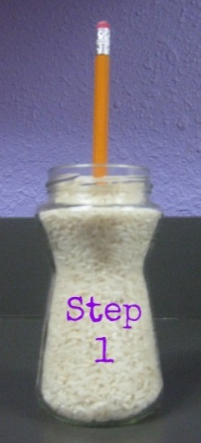 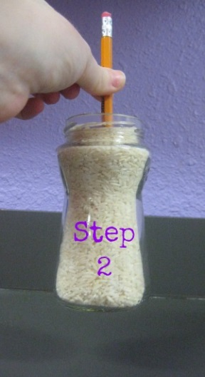

**Experiment #1: Screaming Balloon** (from Steve Spangler Science)

**Estimated hands-on time: 10 minutes**

**Work in groups of 2 or as a classroom demonstration**

**Materials:**

* Latex balloons (9" to 11" diameter size balloons)
* Some 1/4" hex nuts from the hardware store
* Marbles
* Pennies

**Preparation:**

1. Set out balloons, marbles, hex nuts and pennies at the table.
2. Docents may need to assist students in tying the balloons.

**Instructions:**

1. Each group will take two balloons, one marble or penny and one hex nut.
2. Squeeze the marble or penny through the mouth of the balloon. Make sure that the marble goes all the way into the balloon so that there is no danger of it being sucked out while blowing up the balloon.
3. Blow up the balloon. Do not over inflate. Tie off the balloon.
4. Grip the balloon at the stem end as you would a bowling ball. The neck of the balloon will be in your palm and your fingers and thumb will extend down the sides of the balloon.

[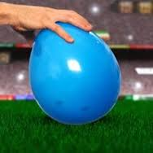](http://www.google.com/imgres?imgurl=https://s-media-cache-ak0.pinimg.com/236x/aa/55/99/aa559912048def4f3849c400e2473233.jpg&imgrefurl=https://www.pinterest.com/alipopper/music-lessons-pitch/&h=236&w=236&tbnid=dQWqkGYNy05z1M:&docid=8N6V-8XtUPbxPM&ei=kjwDVvKGGc-ioQTEtZ7YDw&tbm=isch&ved=0CCkQMygMMAxqFQoTCPKXhJiujsgCFU9RiAodxJoH-w)

1. While holding the balloon, palm down, swirl it in a circular motion. The marble may bounce around at first, but it will soon begin to roll around the inside of the balloon. What is that sound? Is there any sound?
2. Next, in the second balloon squeeze the hex nut through the mouth of the balloon. Make sure that the hex nut goes all the way into the balloon so there is no danger of it being sucked out while blowing up the balloon.
3. Blow up the balloon. Do not overinflate, as it will easily burst. Tie off the balloon.
4. Again grip the balloon at the stem end as you would a bowling ball. The neck of the balloon will be in your palm and your fingers and thumb will extend down the sides of the balloon.
5. While holding the balloon, palm down, swirl it in a circular motion. What is that sound? Is it the same as the marble? Why do you think they make different sounds?
6. Once the hex nut begins to spin, use your other hand to stabilize the balloon. Your hex nut should continue to spin for 10 seconds or more.
7. What happens when you change the size of the balloon or the size of the hex nut? Experiment with other objects whose edges may vibrate against the balloon.

**How Does It Work?**

This experiment actually shows the science of motion and sound. The hex nut circles inside the balloon due to *centripetal* force. Centripetal force is the inward force on a body that causes it to move in a circular path. It is a “center-seeking” force. A hex nut has 6 sides, and these flat edges cause the hex nut to bounce or vibrate inside the balloon. The screaming sound is made by the sides of the hex nut vibrating against the inside wall of the balloon.

**Instructional Video:**

<http://www.bing.com/videos/search?q=screaming+balloon+experiment&FORM=VIRE3#view=detail&mid=D56221A6505A00F8E4A1D56221A6505A00F8E4A1>

**Clean-Up Tips:**

1. At the end of the session pop all the balloons and save the pennies, marbles and hex nuts for other classes.

**Experiment #2: Balloon Powered Fountain**

**Estimated hands-on time: 20 minutes**

**Work in groups of 2-3**

[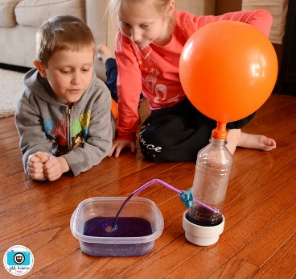](http://www.flickr.com/photos/50806695@N04/12641400755/)

**Materials:**

* Empty 2 liter soda bottles or smaller liter water bottles (one per group)
* Balloons (one per group plus a couple of extra)
* Straws (one per group)
* Modeling clay
* Plastic tray with high sides for catching the water
* Food coloring
* Scissors or Ex-Acto blade

**Preparation:**

1. Before class arrives prepare empty bottles by punching a small hole in the bottle with scissors or an Ex-acto blade. The hole must be no larger than the diameter of the straw.
2. Set out plastic trays, water bottles, modeling clay, straws and food coloring at each seat. Alternatively you can have an area set aside with all the materials. Then have the students responsible for picking out their own materials.
3. Set out pitchers of water.
4. Docents may want to make a sample of the fountain for the students.

**Instructions:**

Questions to ask-

1. Begin by blowing up a balloon. Ask the question, “What is inside the balloon?” *(Air – a gas).*
2. Let the air out.
3. Next take the empty water bottle and ask the students the same questions, “What is inside the bottle?” (*It looks empty but it is actually filled with air.*)
4. Blow up the balloon again and put it over the mouth of the empty bottle without letting too much air escape.
5. Ask the students, “Why isn’t the balloon going down?” *Explain that the balloon is not going down because the bottle is full of air so the air inside the balloon has nowhere to escape.*

Making the Water Bottle Fountain –

1. Take a straw and insert it into the hole in the empty the empty bottle. Seal the opening around the straw with modeling clay so air doesn’t escape. Make sure the bottle is not wet or the modeling clay with not stick.
2. Make sure the straw is pointing up. Ask the students if they can predict what will happen when water is added.
3. Pour water into the empty bottle and add food coloring. The water needs to be at the same level as the top of the straw. Ask the students to guess or hypothesis what will happen.
4. Blow up the balloon, hold it closed with your fingers and then put the mouth of the balloon over the top of the water bottle.

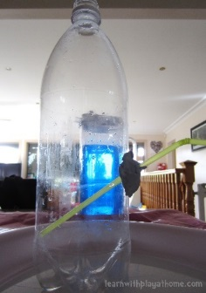

1. What happened? (*The air in the balloon pushed down on the water and forced it up the straw.)*

**Instructional Video:**

<https://www.youtube.com/watch?v=FER3HqaGY3Q>

**Clean-up tips:**

* 1. Discard all the colored water. Rinse the bottles and save for other classes.
  2. If the clay is salvageable place in plastic bags for other classes to use.

**Experiment #3: Marshmallow Catapult**

**Estimated hands-on time: 20 minutes**

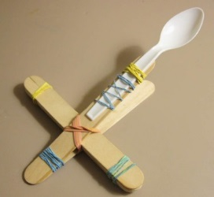

**Materials:**

* Popsicle/craft sticks (9 per student)
* Rubber bands (about 6 per student)
* Plastic spoon (one per student)
* Marshmallows
* Markers
* Marshmallows, pompoms or ping pong balls

**Preparation:**

1. Set out craft sticks, rubber bands, markers and plastic spoons at the table. Students can pick out their own supplies.
2. Docents should hand out marshmallows after the student has completed their catapult.

**Instructions:**

**Step 1** – Take 7 of the craft sticks and tie a rubber band tightly around one end.

[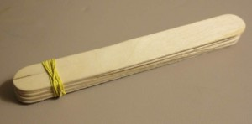](http://www.devincollier.com/wp-content/uploads/IMG_2242.jpg)

**Step 2** – Tie another rubber band tightly around the opposite end so all 7 sticks are bound together.

[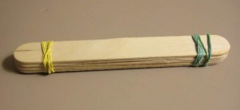](http://www.devincollier.com/wp-content/uploads/IMG_2240.jpg)

**Step 3** – Take the remaining 2 sticks and tie a rubber band on one of the ends. Try to tie the band close to the edge of the sticks.

[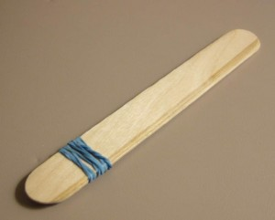](http://www.devincollier.com/wp-content/uploads/IMG_2239.jpg)

**Step 4** – Insert the 7 sticks banded together through the 2 stick bundle as shown in the illustration below.

[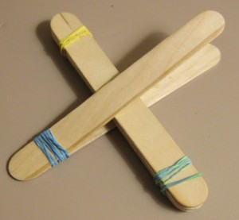](http://www.devincollier.com/wp-content/uploads/IMG_2237.jpg)

**Step 5** – Tie a rubber band in a cross fashion joining the two pieces. The closer the 7 stick bundle gets to the edge, the more leverage the catapult will have.

[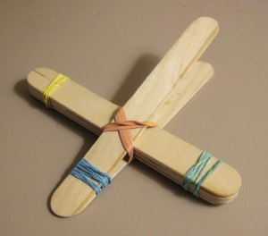](http://www.devincollier.com/wp-content/uploads/IMG_2235.jpg)

**Step 6** – Use a few rubber bands and attach the plastic spoon on the end.

[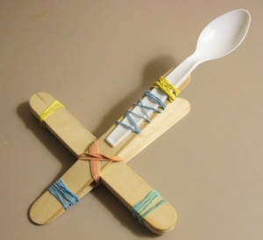](http://www.devincollier.com/wp-content/uploads/IMG_2232.jpg)

**Step 7** – Aim and fire!! Have the students write their names on their catapult. They can even use markers to decorate their catapult. The catapults can go home with the students.

**How it Works:**

Catapults use projectile motion to move objects across distances. A couple of factors can affect the distance an object can be launched, such as the mass of the object, and the amount of force used to move the object.

**Force** - a push or pull. A force can make something start moving, stop moving, or change direction.

**Work** – work is done when we use a force (a push or pull) to move something over a

distance.

**Energy** - the ability to do work. If I have no energy, I can’t use force to make something

move!

There are different kinds of energy

* Kinetic Energy – the energy of motion.
* Potential Energy – is stored energy – it has “potential” to do something.
* Elastic potential energy – an elastic can store energy and convert it to motion when it is released.
* Gravitational potential energy – is the energy an object has when we raise it off the ground.
* Chemical potential energy is the energy stored in chemical bonds of molecules

**Potential Questions to discuss with the class:**

1. What form of energy is used in the catapult? (Potential and kinetic energy)
2. How does the catapult demonstration the laws of motion? (For every action there is an equal and opposite reaction)
3. Were you able to increase the accuracy of your catapult? Give some examples how.