***Snail Investigation Experiment***

**Objective:**

Students will get the opportunity for hands-on observation and investigation of garden snails. The experiments will help to encourage student to think about what snails eat, how they move and their place in the environment. By direct observation students will be more appreciative of some of the wonders of the natural world and gain respect for other living creatures.



[**LS1.B: Growth and Development of Organisms**](http://www.nap.edu/openbook.php?record_id=13165&page=145)

* [Reproduction is essential to the continued existence of every kind of organism. Plants and animals have unique and diverse life cycles. (3-LS1-1)](http://www.nap.edu/openbook.php?record_id=13165&page=145)

[**LS3.B: Variation of Traits**](http://www.nap.edu/openbook.php?record_id=13165&page=160)

* [Different organisms vary in how they look and function because they have different inherited information. (3-LS3- 1)](http://www.nap.edu/openbook.php?record_id=13165&page=160)
* [The environment also affects the traits that an organism develops. (3-LS3-2)](http://www.nap.edu/openbook.php?record_id=13165&page=160)

_____________________________________________________________________________________

**Docent Lab Guidelines:**

1. **Please emphasis to the students this is an experiment to observe and respect snails. They are not to be harmed in any way. They must be handled gently.**
2. **There are rubber gloves available for students who do not want to touch the snails. Hint: Do not offer then unless you see a student with issues otherwise all the students will want them.**
3. **Schedule a date and time with your teacher to have the students come into the lab. Allow at least 60 minutes for this lab, more if you would like to have a final discussion at the end of class.**
4. **Input the day and time into the Science Lab Master Schedule. Please make sure you add set up and clean up time to the class time.**
5. **Allow 30 minutes to set up before class and 30 minutes to clean up afterwards.**
6. **Have a short discussion on snails and their life cycle. There are some snail slides available on the IPad’s under the camera app. Also discuss that even though snails are garden pests they are a very important part of the animal food chain.**
7. **Check with the teachers to see if they would like to take their habitats back to the classroom or leave them in the Science Lab.**
8. **PLEASE NOTE:** Docents are not required to do all parts of Experiment #1. Pick and choose which ones you would like to do or all if you would like.

_____________________________________________________________________________________

**General Docent Information – For Reference**

**Types of snails**  
There are snails with shells and those without. Snails live on land or in freshwater. They belong to a group of animals with a soft body called molluscs (mollusks). A snail is most active at night and on cloudy days. Snails do not like hot and dry conditions. They like it moist or humid and not too bright.

|  |  |
| --- | --- |
| **Basic Features:**   * *Eye spots* at the tips of slender *tentacles*. The tentacles feel what the simple eye spots may not see. In land snails with two *pairs* of tentacles, the eye spots reside on the longer upper pair. * *Mouths* directed downward so that food can be taken from the surface being traveled over. Watching an aquatic snail through aquarium glass, you can see the snail's raspy tongue methodically scraping algae off the glass * Single, broad, muscular, flat-bottom *feet*, which move the creatures forward   Head of Banded Forest Snail, MONADENIA FIDELIS, showing four tentaclesThe picture at the right shows the head of a Banded Forest Snail, *Monadenia fidelis*, a common species in the US Pacific Northwest. Notice that this land snail's head bears four long appendages called **tentacles**, which are used to feel. The rounded tips are primarily odor-sensing *chemoreceptors* that enable the snail to smell its environment. The upper two tentacles also bear eye spots at their tips enabling the snail to detect movement and shades of gray.  Breathing hole of Banded Forest Snail, MONADENIA FIDELISAt the left you see the **breathing hole** of the Banded Forest Snail shown above. |  |
| |  | | --- | | Slug  On the above slug, notices that where a snail’s shell would be there’s a long, leathery thickening almost as if the slug were wearing a cape. That's the **mantle fold**. Toward the back in the mantle fold you see a hole. That's the air hole. A more technical name for the air hole is **pneumostome**. The top pair of tentacles, the ones bearing the eye spots, is technically known as the **cephalic tentacles**. The lower pair of tentacles is the **oral tentacles**. The lowest part of the slug, here showing many vertical stripes at its side, is the **foot**, and the foot's bottom surface, which glides over things, is -- you guessed it -- the **sole**.  Cross section of a snail shellThe image at the right shows a cross section of a snail shell. The *top* of the shell has been removed.  The shell is hard, so it had to grow in a special way, in a spiraling manner. The part of the shell that grew was the rim surrounding the protruding foot. The rim grew as if it were adding slender, ever larger rings, each below the last. In the image, the dark cavity on the shell's left is where the snail's foot emerged from the intact shell.  **HOW SNAILS & SLUGS MOVE:**  A snail propels itself by sending wave after wave of small contractions forward from the back of its foot toward the front. If you've lain on your back and inched yourself across the living-room floor by alternately curving and straightening your backbone, you understand the principle.  **CLASSIFICATION:**  The mollusk *phylum* contains several *classes* and *subclasses*. One class holds octopuses and squids. Clams and oysters belong in another; and then there's the snail and slug *class*. The snail and slug class is itself huge and diverse, and all its members are known collectively as **gastropods**. The word gastropod is almost funny: It's derived from the classical Greek word *gastros* meaning stomach, and *podos* meaning foot. Watching aquarium snails grazing, you may think that "stomach-foot" is a good name for them!  **LAND SNAILS & MUCOUS FACTS**  The vast majority of gastropods are aquatic animals. In fact, snails and slugs are the only mollusk class found on land. The snails in our backyards should more precisely be called *land snails*.  One adaptation enabling land snails and slugs to survive on land is their ability to produce plenty of slimy mucous. If you've watched a land snail or a slug moving across a dry surface, you may have noticed that it left a silvery trail. This trail is **mucous** the creature lays down beneath it as it travels Land snails and slugs move upon a layer of mucous.  This mucous in wonderful stuff. For one thing, it prevents moisture in the animals' bodies from being soaked up by the dry terrain being traveled across. Also, it protects the animal's fleshy underparts from sharp objects. Snails and slugs can actually glide across the sharpest razor blade without cutting themselves.  The big danger in the lives of land snails and slugs is *drying out*. Gardeners know that one way to rid themselves of lettuce-eating snails and slugs is to sprinkle them with salt. The salt causes water to leave their bodies, and they shrivel up fast!  When dry weather comes, land snails and slugs bury themselves in the soil or find some other well protected spot. Snails plug up their shell holes with mucous, and slugs secrete a sort of mucousy cocoon for themselves. Then through the dry spell the animals remain in a state of suspended animation during which their body processes slow to a point almost like death. However, there's enough life in them for them to become active again once enough rain comes to dissolve the mucous and soak into their bodies.  Mucous also comes in handy when a predator such as a toad snatches up a seemingly defenseless slug. The slug secretes such quantities of the stuff that after the toad chews a few times it finds its mouth clogged with sticky, gooey slime. | | |

**Snail Anatomy**

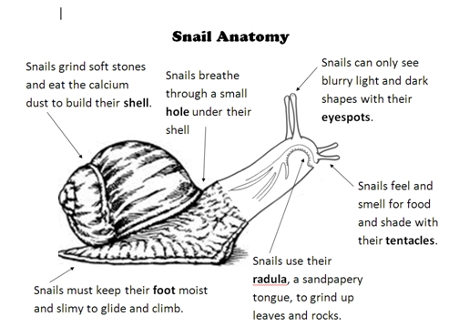

**Snail Cross Section**

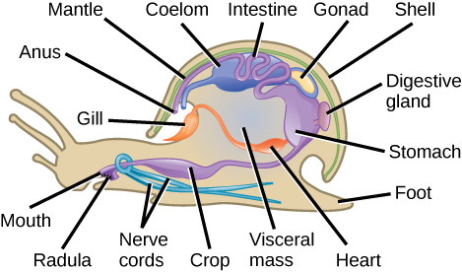

**Experiment #1: Snail Investigation (work in pairs)**

***Estimated time: 25-30 minutes***

**Materials:**

* Clear plastic trays
* Snails (one per group of 2)
* Flour paste (a mixture of water and flour)
* Q-tips to spread flour paste.
* Magnifying glasses
* Empty snail shell
* Small piece of sandpaper
* Spray bottles with room temperate water – 1 per table group
* Paper towels

**Preparation:**

* Before class starts prepare the flour paste. Mix a small amount of flour with water to make a thin paste. Spoon about a tablespoon of the flour paste in 4-5 small bowls. There should be one bowl for each table.
* Place the trays, spray bottles, magnifying glasses and eye protection on the tables before the class arrives.
* Place (1) copy of the snail anatomy at each table or put on the overhead projector.
* Wait to hand out the empty snail shells when you get to that part of the experiment, otherwise the kids will just play with them.

**During the Experiment:**

*Hand out a snail to each pair. Walk through each step of this experiment with the class. Do each part of the experiment together, talking them through it.*

**Can snails see and smell?**

The snail has two pairs of tentacles on its head. The tentacles are very important to the snail. The snail's eyes are on the tip of the longer tentacle, or at the base of the tentacle for water species. The shorter pair is used for smelling and feeling its way around. Have the students carefully observe the tentacles with the magnifying glass. Can they see the snail’s eyes?

**How do snails move?**

Ask children if they have ever watched a snail moving slowly across the ground and wondered how it was able to move since no "legs" were showing. Explain that the whole bottom part of a snail's body is really a "foot." This foot is flat and smooth and contains muscles which the snail uses to glide along the ground. To help it move more easily, this foot has tiny glands which give out a slimy fluid, so the snail really glides over the surface with a wave-like movement.

* *Hold up the tray with the snail on top and watch from below how the snail is moving the foot's muscle to move.*

**How do snails eat?**

Most snails eat plants of various kinds. The snail has a tongue that is like a file, with hundreds of tiny teeth. It uses this to cut and shred its food.   
*Have the students spread a small amount of the flour paste with their finger* ***onto the tray next to the snail****. This works best with inactive hungry sails. See if the snail will feed on the flour mixture. Watch from underneath how the snail is eating the flour mixture. What are the snails “teeth”? How does it feed on the flour mixture?*

**What can snails sense?**

Gently touch different parts of the snail’s foot. What does the snail do? Next touch its shell. Can it feel you?

**The snail's shell (Optional)**

The snail that lives in a shell has a body that fits right into the coil of the shell, and it has strong muscles that enable it to pull its body entirely into the shell when there is danger. As an added protection when the body is in the shell, a horny disc at the end closes the opening tightly.

If there are empty snail shells available for this lesson try looking inside a shell. Carefully rub an empty snail shell on sand paper until you have worn it down to show the inside of the shell ***(docent may want to do this part for the students)***. What type of pattern do you see inside the shell? How are the holes connected? Where would the body and foot of the snail be found in the shell when it draws itself in?

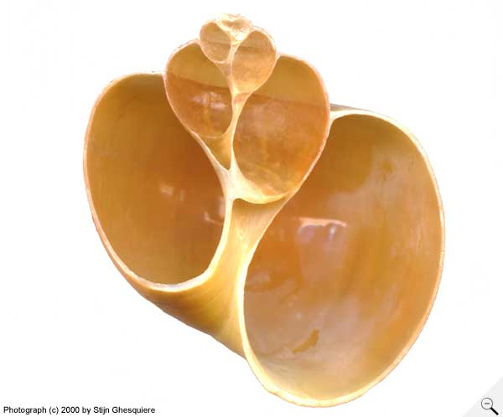 **Snail shell cross section**

**Tips:**

* This experiment is best if done with at least one docent per table group. If there is not enough docents than have the lead docent guide the entire class through all the steps above at the same time.
* If the snails are not fed for a couple of days prior to the experiment they will be very eager to eat and the student will have success watching them eat.
* Use the clear plastic trays. It allows for students to pick up the trays and observe from below.
* Some students may try to feed the snail like a baby. Make sure the flour paste is placed ONLY on the tray and not directly on the snail’s body.
* The snails may be inactive when they are first brought out. To encourage movement dim the lights and gently spray with room temperature from the water bottles.
* Docents should keep the spray bottles otherwise there will be a lot of over spraying.

**Experiment #2: Make a Snail Habitat (work in table groups preferably 3 groups)**

***Estimated time: 10 minutes***

|  |
| --- |
| **Materials:**   * **Plastic Habitat Container** * **Gravel** * **Soil** * **Rocks** * **Grass, moss or leaves** * **Sticks or bark** * **Snail Food: fresh green leaves, vegetable pieces, small plants with roots, cuttlebone** * **dark construction paper or dark cloth** * **spray bottle filled with water**   **Preparation:**  Before class starts prepare a tray(s) with the materials needed to make a habitat. Put holes in the lids of the container if there is none already.  After Experiment #1 is completed remove the equipment from the tables and bring out the trays with the habitat materials.  **What you do:**  To prepare the snail home, layer the bottom of the other aquarium with gravel. Place two inches or more of moist soil on top of the gravel. Add plants if available and decorate with rocks, sticks and grass to give the home a natural look. Add leafy greens for food or vegetables. Keep the container covered with a piece of dark paper or tape dark construction paper on the habitat when not being used by children for observation. A dark cover may encourage snails to lay eggs.  Add snails to the temporary homes. Place the container on a table in a cool area of the room where children can sit and observe the activities of the snails. Do not place directly next to a window or heater. Include magnifying glasses, and spray bottles filled with water near the habitat. Encourage children to record daily observations of the snails with words and drawings.  Keep the soil in the container moist by spraying gently with the water bottles. Show children how to mist the soil so that it becomes damp but not waterlogged. Release the animals back into the wild when the unit is complete. |

**Clean Up Notes:**

1. **Discard the used flour paste and Q-tips in the trash.**
2. **Save used portions of soil, gravel, rocks, bark and sticks.**
3. **Do not pour sand or soil in the sink.**