***The Plant Life Cycle***

**Objective:**

Students will learn about the plant life cycle by hands-on observation and planting of bulb vegetables and/or plants. The experiments will be used to encourage student to think about the importance of the Plant Life Cycle and its benefits to humans.



[**LS1.B: Growth and Development of Organisms**](http://www.nap.edu/openbook.php?record_id=13165&page=145)

* [Reproduction is essential to the continued existence of every kind of organism. Plants and animals have unique and diverse life cycles. (3-LS1-1)](http://www.nap.edu/openbook.php?record_id=13165&page=145)

_____________________________________________________________________________________

**Docent Lab Guidelines:**

1. **Schedule a date and time with your teacher to have the students come into the lab. Allow 45 minutes to 1 hour of class time.**
2. **Input the day and time into the Science Lab Master Schedule. Please make sure you add set up and clean up time to the class time.**
3. **Allow 30 minutes to set up and 30 minutes of clean up time.**
4. **Give a brief discussion on the plant life cycle. There will be some books available if you would like to read the class a book. The books will be placed in the vertical files. Or you can opt to show the class a video.**
5. **Check with the teachers to see if they would like to take their plants back to the classroom or leave them in the Science Lab.**

**General Docent Information**

There will be a children’s book available on how plants grow. In lieu of a formal discussion you can choose to read this book or incorporate it into the class discussion before you start the experiments.

The experiment portion will involve planting some bulb vegetables and/or plants.

Feel free to put the Parts of a Plant diagram and / or Plant Life Cycle on the overhead projector if needed for discussion purposes.

As an option (not required) the docents can choose to do Experiment #2. Use magnifying glasses to observe different type of plant leaves and seeds. Also if a magnifying glass is taped to the camera lens of the iPad it can be used as a make shift microscope.

**The Plant Life Cycle Diagram:**

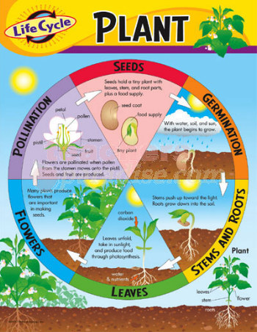

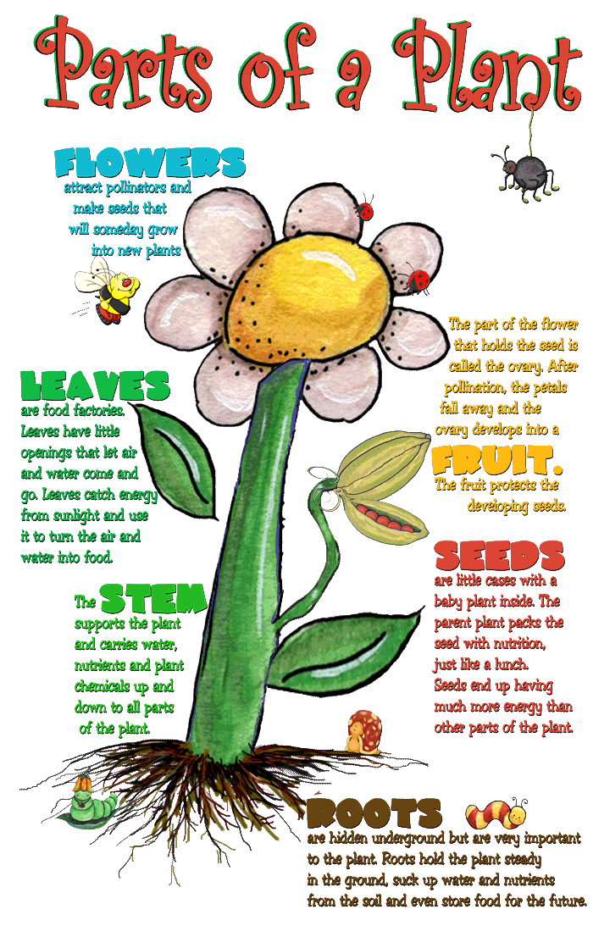

**Video on the Plant Cycle:**

1. Dinosaur Train: Nature Life Cycle (run time 2 min. 38 sec.)

<http://www.pbslearningmedia.org/resource/0c0da038-4ed9-47fd-b108-3d155f05a0b3/0c0da038-4ed9-47fd-b108-3d155f05a0b3/>

1. How Does a Plant Grow – Time Lapse (run time 1 min. 7 sec.)

<http://www.pbslearningmedia.org/resource/tdc02.sci.life.colt.plantsgrow/from-seed-to-flower/>

1. Dinosaur Train: Flowers that Last Forever

<http://www.pbslearningmedia.org/resource/c23141f7-63eb-4667-a9c5-fb04f4795885/c23141f7-63eb-4667-a9c5-fb04f4795885/>

**Experiment #1: Planting**

***Estimated time: 15-20 minutes***

**Materials:**

* Empty pots and or containers
* Soil
* Bulbs (Freesias, gladiolus, onions or garlic)
* Labels, markers and popsicle sticks for Names
* Water
* Spoons or cups for scooping soil

**Preparation:**

* Set out 1-2 containers per table based on how many containers are available.
* Set out bowls of soil and scooping utensils (or hands works perfectly too).
* Set out bulbs at each table.
* Create a table with markers, Popsicle sticks and labels for kids to make signs for their planter identifying what they have planted and their names.

**Instructions:**

1. Students will work at table groups.
2. Scoop soil into the container.
3. Place bulbs at the appropriate depth based on the type of bulb.
4. Add water.
5. Create labels for each planter.
6. Add water.

**Experiment #2: Plant Investigation**

***Estimated time: 15 minutes***

**Materials:**

* Various plant leaves, flowers and seeds
* Magnifying glasses
* Zoomy microscope
* Computer

**Preparation:**

* Before class starts boot up the computer and start the Zoomy microscope program.
* Place magnifying glasses on the tables for students to view plant specimens on their own.
* Prepare trays with leaves and plants to investigate.

**Instruction:**

1. Have the student’s magnifying glasses to look at the details of various plants and flowers. What do they see? Can they name the parts of the plant or flower?
2. You can also take the students to the computer station and have them view plant specimens with the Zoomy microscope. Just put the microscope over the specimen and turn the top of the microscope to zoom in an out.

**IPad Resource: The Science of Gardening from the SF Exploratorium**

If you are interested in using the IPad to show the kids some interesting close up photos of different flowers take a look at the ***Secret Lives of Flowers*** at:

<http://www.exploratorium.edu/gardening/bloom/secret_life_of_flowers/index.html>