The Science of Light & Color
Objective:
Students will learn that color comes from light. They will explore primary colors and what happens when primary colors are mixed together.

Docent Lab Guidelines:
- Schedule a date and time with your teacher to have the students come into the lab. Allow at least 1 hour of class time if not more. It may get a little messy.
- Input the day and time into the Science Lab Master Schedule. Please make sure you allow about 30 minutes of set up time and 30 minutes of clean up time.
- If you are shorthanded discuss with your teacher the possibility of having some Big Buddies in the lab to help.
- Have students wear a lab apron and safety glasses.
- Have students sit on the carpet at the start of class. Since this is the first lab session review the lab rules.
- Give a brief 5-10 minute discussion on light and color then proceed with experiments. The discussion is very basic at this age: (1) what we call light is what is visible to us (2) light is energy and keeps us alive (3) light contains all the colors of the rainbow.
- There are videos lists below which can be show to the class in lieu of a formal discussion.
- There are three experiments that are set up at three tables. The students will rotate to each station.
- Keep track of time and alert the students when it is time to rotate. About 10-12 minutes per station.
- Allow enough time for students to wash up afterwards. Girls can wash up in the adjacent girl’s restroom.
_____________________________________________________________________________________
General Docent Information about the Subject Matter – For Reference Only
What is light?
Science is a unique collaboration between human perceptions and our ability to reason and build ideas. The concept of light is an appropriate starting point for building an understanding of science because it is through the interaction of light, our eyes, and our brain that we collect most of the information we have about the world.
Today scientists say light is a form of energy made of photons. Light is unique in that it behaves like both a particle and a wave. Depending on the type of matter it comes into contact with, light will behave differently. Sometimes light will pass directly through the matter, like with air or water. This type of matter is called transparent. Other objects completely reflect light, like an animal or a book. These objects are called opaque. A third type of object does some of both and tends to scatter the light. These objects are called translucent objects.
Without sunlight our world would be a dead dark place. Sunlight does more than just

help us see it also keeps the Earth warm, so it's not just a frozen ball in outer space. It also is a major component in photosynthesis which is how most of the plant life on Earth grows and gets nutrients. Sunlight is a source of energy as well as a source of vitamin D for humans.
Light moves at the fastest known speed in the universe. Nothing moves faster than (or even close to) the speed of light. In a vacuum, where there is nothing to slow it down, light travels 186,282 miles per second! Wow, that's fast! When light travels through matter, like air or water, it slows down some, but it's still pretty fast.
To give you an idea as to how fast light is, we'll give you some examples. The sun is almost 93 million miles from the Earth. It takes around 8 minutes for light to get from the sun to the Earth. It takes around 1.3 seconds for light to go from the moon to the Earth.

How do we see color?
The human eye and brain together translate light into color. Light receptors within the eye transmit messages to the brain, which produces the familiar sensations of color. Considered to be part of the brain itself, the retina is covered by millions of light-sensitive cells, some shaped like rods and some like cones. These receptors process the light into nerve impulses and pass them along to the cortex of the brain via the optic nerve
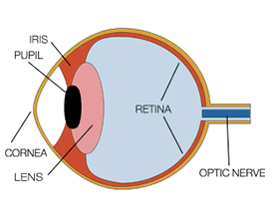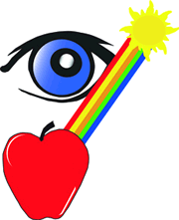
Newton observed that color is not inherent in objects. Rather, the surface of an object reflects some colors and absorbs all the others. We perceive only the reflected colors.
Thus, red is not "in" an apple. The surface of the apple is reflecting the wavelengths we see as red and absorbing all the rest. An object appears white when it reflects all wavelengths and black when it absorbs them all.
What are primary colors?
Red, green and blue are the additive primary colors of the color spectrum. Combining balanced amounts of red, green and blue lights also produces pure white. By varying the amount of red, green and blue light, all of the colors in the visible spectrum can be produced.
What is the color wheel?
Color wheels show us how colors are related. They remind artists how to mix and think about colors. The primary colors are: red, blue, yellow.
Primary colors cannot be made from other colors. Artists create all the other colors of the rainbow by mixing together the primary colors. The secondary colors are: green, orange, and violet (purple).
Secondary colors are made by mixing two primary colors. Each secondary color is made from the two primary colors closest to it on the color wheel.
Are the colors black and white the absence of color?
Black and white are a bit different from other colors. White is a combination of all colors, so when we see white, the object is reflecting all the colors of light the same. Black is the opposite. When we see a black object that means almost all the colors of light are being absorbed.

It's not how it is—it's how you see it
Many of the things we think are true of the world turn out to be true only of ourselves. We think apples are red, but in fact we only see them that way. If our eyes were built differently, we might see the light photons that apples produce as light of a totally different color. And there's no real way any of us can be sure that what we see as "red" is the same as what anyone else sees as red: there's no way to prove that my red is the same as yours. Some of the most interesting aspects of the things we see come down to the psychology of perception (how our eyes see the world and how our brains make sense of that), not the physics of light. Color blindness and optical illusions are two examples of this.
Understanding light is a brilliant example of what being a scientist is all about.
Videos:
Sid the Science Kid: Let there is Light (6 minutes – very basic concepts)
http://www.pbslearningmedia.org/resource/47861fd4-683a-4924-b490-3d53055309af/47861fd4-683a-4924-b490-3d53055309af/
Professor Science: Color Mixing (1 min. 45 sec.)
http://www.pbslearningmedia.org/resource/1c280f9a-2797-4ad8-bdee-cbc858bc6bf1/color-mixing/
Peep In the Big Wide World: A Peep of a Different Color (8 min. 50 sec.)
http://www.pbslearningmedia.org/resource/rtttec13.ela.fdn.padiff/a-peep-of-a-different-color/
The Color Wheel for kids (3 min. 39 sec.)
https://www.youtube.com/watch?v=eGrGkJtSLsk
Primary Colors for Kindergarten (2 min. 30 sec.)
https://www.youtube.com/watch?v=ZUflBoJQfpQ

Rainbows and Refraction (1 min. 2 sec.)
https://www.youtube.com/watch?v=q73VNpFA-0Q
Brown Science Center: How do we see color? (4 min. 2 sec. - For docent information)
https://www.youtube.com/watch?v=pvC9MQvqHMQ

Experiment #1: Sharpie Tie-Dye (From the Steve Spangler Science. This activity is the creation of Bob Becker, a chemistry teacher in Kirkwood, Missouri.)
Estimated student hands-on time: 10 minutes
This experiment needs to be set up outside with at least one docent to monitor 6-8 students at a time.
Main concept Goal:
To give students an understanding of color blending.

Materials Needed:
- Materials Large-mouth plastic cup or bowl
- Rubber bands
- 91% isopropyl alcohol
- Sharpie® pens, various colors
- Piece of white cotton fabric
- Dropper squeeze bottle
- Black Sharpie marker (for writing students names on fabric)
Preparation:
- Before class starts set up a table outside or use the half circle concrete bench at the end of the corridor. The activity is short so there is no need to bring chairs outside.
- Set out plastic cups/bowels, rubber bands, sharpies at lab station.
- Make sure the dropper squeeze bottles are filled with alcohol.
- Pre-Cut fabric into 6x6 squares
Possible questions to ask students to think about before/during/after the experiment:
- What do you predict will happen when you add the alcohol to the pen markings?
- Did the colors blend together or stay separated? If they blended together what new colors did you make?
- How do you think this happens?
- What new color is made by blending two colors together?

Instructions:
Warning: Rubbing alcohol is very flammable and must be kept away from any open flames or heat. This experiment should be conducted outside. DO NOT INGEST.
- Place the plastic cup inside the middle of the fabric.
- Position the opening of the cup directly under the section of the fabric or coffee filter that you want to decorate.
- Stretch the rubber band over the material and the cup to secure the material is in place. Docents to assist with the rubber bands.
- Place dots or circles of ink from the sharpie markers in a circle pattern about the size of a quarter in the center of the stretched out fabric. If you like, use another color marker to fill in spaces in between the first dots. There should be a quarter size circle of dots in the middle of the plastic cup opening when you are finished.
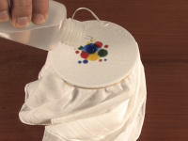
- Slowly squeeze approximately 20 drops of rubbing alcohol into the center of the circle of dots. DO NOT flood the design area with rubbing alcohol. The key is to drip the rubbing alcohol slowly in the center of the design and allow the molecules of ink to spread outward from the center.
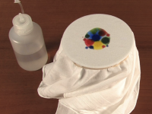
- As the rubbing alcohol absorbs into the fabric, the ink spreads in a circular pattern. The result is a beautiful flower-like pattern.

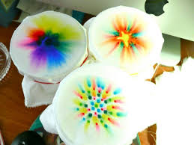
- Apply more alcohol if needed, but do not let the pattern spread beyond the edges of the cup.
- Enjoy experimenting with various patterns, dot sizes, shapes and color combinations. Instead of using dots, try drawing a small square with each side being a different color, or use primary colors to draw a geometric shape and accent it with dots of secondary colors. Half circles, wavy lines, and polygons all make unique patterns when rubbing alcohol travels across the ink.
- After the students have completed their creation make sure their names are on it and set it out to dry.
- The teacher can take all the tie-dye creations with her and distribute them to their students at a later time.

How Does It Work? (For Docent Reference)
The Sharpie markers contain permanent ink, which will not wash away with water. Permanent ink is hydrophobic, meaning it is not soluble in water. However, the molecules of ink are soluble in another solvent called rubbing alcohol. This solvent carries the different colors of ink with it as it spreads in a circular pattern from the center of the shirt.
Video on How-to do the Experiment:
https://www.youtube.com/watch?v=-rKuo22dl08

Experiment #2: Fireworks in a Glass
Estimated hands-on student time: 10 minutes
This experiment is best conducted with at least one docent to monitor 6-8 students at a time.
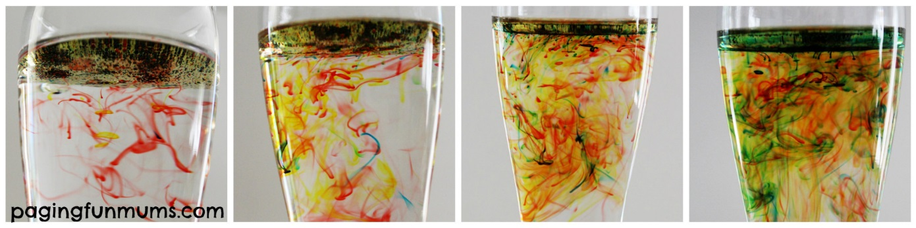
Main concept Goal:
To give students an understanding of color mixing as well as density.

Materials Needed:
- Large beakers or large clear plastic cups
- Small clear cylinder containers
- Plastic spoons
- Variety of Food coloring
- Warm water
- Large thermos or pitchers to store warm water
- Vegetable oil
- Plastic trays (one tray per seat. Used to contain spills)
- Lots of paper towels
- Spoons
- Large white plastic rectangular bin (to pour out used experiments)
Preparation:
- Before class arrives heat up water in the microwave and store in several pitchers or a large Thermos. Make water a kid friendly temperature. Set water on table.
- Set out a roll of paper towels on the table and strategically place a trash can nearby.
- Set out food coloring and spoons around the table.
- At each seat place (1) place clear plastic tray, (1) beaker or plastic cup inside the tray and (1) small clear plastic cylinder container.
- Either place oil in smaller measuring cups with spouts that kids can handle themselves or set aside larger bottles of oil away from the table in a location for docents to grab and pour for each student.
- Place 1-2 large white bins in the center of the table to pour out experiment when completed. This will help docents quickly clean up the station for the next rotation without having a long line of students waiting to pour out their experiment at the sink.
Instructions:
- Fill the beaker or cup 3/4 of the way to the top with warm water.
- In a separate glass add a few table spoons of oil and add 4 drops of food coloring – of differing colors.
- Using a spoon, give the oil and food coloring mixture a good mix to break up the ‘color beads’ into smaller ones

- Carefully pour the oil & food coloring mixture into the glass of warm water and wait for the magic to happen!

How Does It Work? (For Docent reference)
Food coloring dissolves in water, but not in oil. When you stir the food coloring in the oil, you are breaking up the coloring droplets (though drops that come into contact with each other will merge… blue + red = purple). Oil is less dense than water, so the oil will float at the top of the glass. As the colored drops sink to the bottom of the oil, they mix with the water. The color diffuses outwards as the heavier colored drop falls to the bottom.

Experiment #3: Color Mixing Station
Estimated hands-on student time: 10 minutes
This experiment is best conducted with at least one docent to monitor 6-8 students at a time.
Main concept Goal:
Introduces the basic color wheel. Students discover three primary colors can be mixed into endless possibilities.

Materials Needed:
- Clear Plastic cups
- Large soda bottle test tubes
- Plastic spoons
- Test tube racks
- Color fizzer tablets – nontoxic and non-staining
- Pipettes or droppers
- Plastic trays (one tray per seat. Used to contain spills)
- Water
- Lots of paper towels
- Large white plastic rectangular bin (to pour out used experiments)
- Water Jelly Crystals (if available)
Preparation:
- Set out a roll of paper towels on the table and strategically place a trash can nearby.
- At each seat place (1) place clear plastic tray, (1) test tube rack, (6) soda bottle test tubes (1) pipette or dropper, (1) spoon and (3) Clear Plastic cups.
- Put water in small containers that the students can handle. Place these on the table.
- Have fizzing color tablets ready. It would probably be best for the docent to hand out a couple of tablets to each student.
- If available have the water crystals set aside out of reach of the students but places where the docent managing the table can grab them to hand out.
- Put the large white plastic bin out on the center of the table to pour our used colored water. This will help with faster transition between stations.
Instructions:
- Pour water into the three plastic cups.
- Hand out three color tablets to each student (a red, yellow and blue).
- Place one color in each cup of water.

- Next using the dropper (or just pouring by hand) mix the three primary colors in the (6) test tubes to see how many color combinations can be created.
- If available hand out water jelly crystals. Drop (1) jelly crystals into each test tube. What happens to the water jelly crystal?
- When done pour out the colored water and jelly crystals into the large bin(s).
- Replace racks with new test tubes for the next rotations.

Tips & Precautions:
- DO NOT POUR WATER CRYSTALS DOWN THE SINK. Put them in the trash.
- Make sure students are wearing aprons.
- Have a bin of clean test tubes set aside for the next rotation. This way you do not have to be at the sink cleaning test tubes in between rotations.

