Measuring Accurately
Objective: Students will make observations and measurements to produce data to serve as the basis for evidence for an explanation of a phenomenon. (4-ESS2-1) This relates to
Science and Engineering Practices
Planning and Carrying out Investigations
Planning and carrying out investigations to answer questions or test solutions to problems in 3-5 builds on K-2 experiences and progresses to include investigations that control variables and provide evident to support explanations or design solutions.
Analyzing and Interpreting Data
Analyzing data in 3-5 builds on K-2 experiences to introducing approaches to collecting data and conducting multiple trials of qualitative observations. When possible and feasible, digital tools should be used.
- Analyze and interpret data to make sense of phenomena using logical reason (4ESS1-1)
Construction Explanations and Designing Solutions
Construction explanations and designing solutions in 3-5 build on K-2 experiences and progresses to use of evidence in construction explanations that specify variables that describe and predict phenomena and in designing multiple solutions to design problems.
Docent Lab Guidelines:
- Schedule a date and time with your teacher to have the students come into the lab. Allow at least 45minutes of class time. Ideally, it would be better if you can get 1hr. min.
- Input the day and time into the Science Lab Master Schedule. Please make sure you add set up and clean up time to the class time.
- Allow 30 minutes to set up and 30 minutes of clean up time.
_____________________________________________________________________________________
General Docent Reference Information.
The Science of Measurement http://www.imdb.com/rg/VIDEO_PLAY/LINK//video/screenplay/vi747547929/
Slide show of vocabulary related to measurement: http://www.slideshare.net/MsBenesova/measurement-unit-vocabularyword-wall

Ryan S. is an English / Language Arts and Math teacher in both the classroom and online worlds. His favorite students, however, are his three young children. He has these suggestions to teach measurement conversions:

Conversion Gives Students the Chills
Few lessons I cover as a teacher are more dreaded by students and parents alike than teaching how to convert measurement units. Changing between the cups and gallons used in the United States can be tricky enough, let along bringing in the metric system used by other countries.

Tell a Story
From a student’s perspective, measurement units are often seen as something adults made up to make children suffer. They can seem useless and unhelpful to students, and they can wonder they even have to learn about changing measurement units at all. Using measurement in stories and real-world situations can help students see that changing units is not pointless after all.
Choosing a story or situation based on your child’s interest is a sure way to make measurement a little more welcome. Students who enjoy sports might enjoy changing Olympic Records from metric units into feet or miles. Or, students could write their own metric mysteries by creating a story that uses a metric measurement in some way. Shoe” The Land of Gallon” worksheet. Then they could then calculate the measurement conversion to put in the answer. The more the measurements matter to your child, the more motivated they will be.

The Body as a Ruler
Another way I help make measurement conversions a little more tangible is to make it hands on, literally. I have students measure their hands using metric units, and then they see how many hands it takes to measure a familiar object, like the height of the classroom door. By the time they have finished finding the metric answer, those centimeters are not quite so intimidating.
Really, anything that matters to a student makes a great ruler, from a pet to their room at home. However, I usually keep the focus on the students themselves. The measuring your hand activity can also be scaled down to the length of a fingertip (millimeters) or scaled up to the length of an arm (meters). To make measurement conversion personal and more meaningful, what better way than using an actual person?

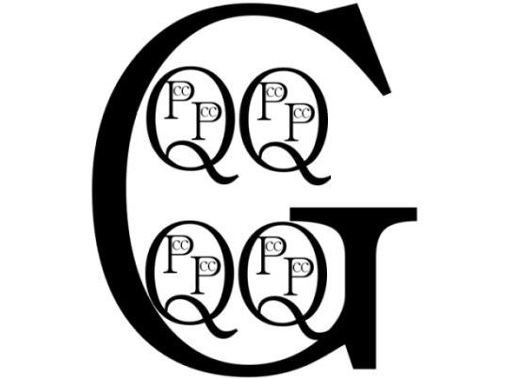A Picture is Worth a Thousand Words
The friendly face at the beginning of this post is more than just a picture. Mr. Gallon shows the power of a picture in helping students see the connections between different units. Students can hear the conversion rules over and over (I should know, I’ve tried), but a good picture can help the information click in a way that numbers alone never can. .[see ‘”Gallon Man” coloring activity].
Of course, even the best of images won’t speak to everyone. Another of my favorite ways to show US liquid measurement is the following. Seeing all the parts nested within one another helps make it clear that the smaller units are the building blocks of the larger ones
Here are some additional website resources:
Length
- Metric Lengths
- US Standard Lengths

Area
- Metric Area
- US Standard Area

Volume
- Metric Volumes
- US Standard Volumes
- Measuring Cups

Mass (Weight)
- Metric Mass
- US Standard Mass
- Weight or Mass?
- Apparent Weight

Measurement Lab
Lab Overview:
This lab is done in pairs after the initial discussion.
Whole Group:
Lead a discussion on when and why we measure, and why accuracy is important i.e. In building anything, in cooking, to insure that we are not overloading something, or in allowing sufficient time to complete something.
Define Measurement: Measurement is finding a number that shows the size or amount of something. We can measure many different things, but mostly we measure Length, Area, Volume, Weight or Mass and Time.
Define Length: Length is the measurement of the longer or longest dimension of an object; "It can reach over two feet in length". This is also called linear measurement.
Define Area: Area is the measurement of the surface included within a set of lines, specifically the number of unit squares equal in measure to the surface. ”The surface area of the room is nine square yards.”
Define Volume: Volume is the amount of space occupied by a substance. “ We need three cups of flour for the cookie recipe.”
Define Weight: Weight : a a measurement of somethings heaviness or mass:
Tell the students that for today they will be working with Linear, or Length, Volume and Weight or mass
Show https://www.youtube.com/watch?v=AuIRdK5IfNo Tagging Tiger Sharks in Hawaii-Hammerheads that shows the importance of accurate measuring.2.23 minutes
Activity 1
Linear measurement
Materials Needed:
Measuring tapes: 1 per pair of students
Metric Me worksheets: 1 per student
Distance: Practice Reading Measurement Laminated copy
Display the laminated sheet. Make sure all students know that they must always examine the measuring instrument, as they are not alike. First, they need to identify the metric vs the standard sides. One measures in centimeters, one in inches. Next, they should note where the zero point is: at the end? Slightly indented? The zero point is where to place the instrument to begin any measurement. Once they know their tool, they are to work with their partner to complete “Metric Me”.
End of activity: Collect Metric Me

Activity 2:
Mass measurement
Materials Needed:
Balances with measuring masses: 1 per pair of students
Weight worksheet: 1 per pair of students
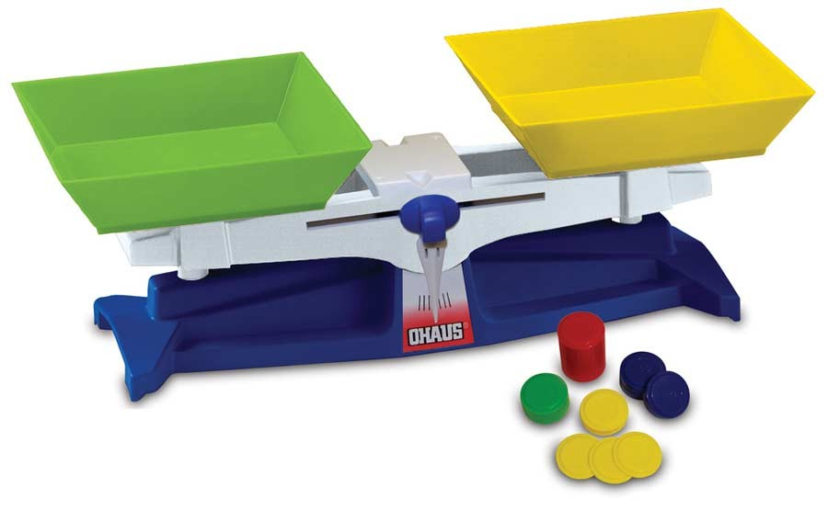
Show students the balance and demonstrate how to make sure the balance is zeroed out/balanced. Note above the downward pointing arrow is exactly in the middle when it is zeroed out..
In pairs, students will find the mass of the items on their Weight work sheet by placing the item being measured in one bucket and slowly adding weighted masses into the other bucket until the scales are balanced. Record the result.

Names: ______________________________________________

Weight/Mass

Using the balance scale, find the mass of the following:

- A pencil ______________________________________

- A book_______________________________________

- A glass jar with lid _____________________________

- Your choice __________________________________

Activity 3: Volume Measurement:
Materials Needed:
Examples of gallon, quart, pint, cup as real examples
Copies of “Gallon Man” and “The Land of Gallon”, allowing one per student – students choose one
Color pencils/crayons
Laminated “Gallon Man”
Story “In the Land of Gallon”
Real life measures: Gallon, quart, pint, cup
Procedure:
- Tell students that you will give them two different ways to remember the “Conversion for the US Standard measures for volume”. Docents to present “Gallon Man” along with real life examples.

- Docents read the “Land of Gallon” story.
“In the Land of Gallon there lived four Queens. Each Queen had two princes. Each prince had two cats.” Can you imagine what the letters really stand for?
Students can color their choice of memory devices. All complete the questions on the reverse. Students to take worksheets to class to put into their binders as a reminder.

