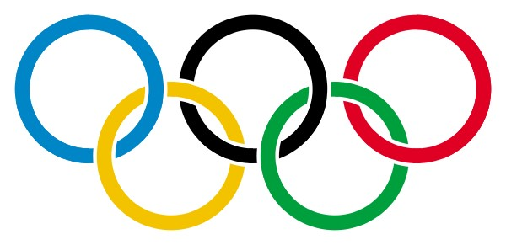

Become an Olympic athlete. Record your stats for Olympic officials. Measure each body part using metric units of length. Color your athlete to represent your favorite country.

**Name ________________________________________________________________________**

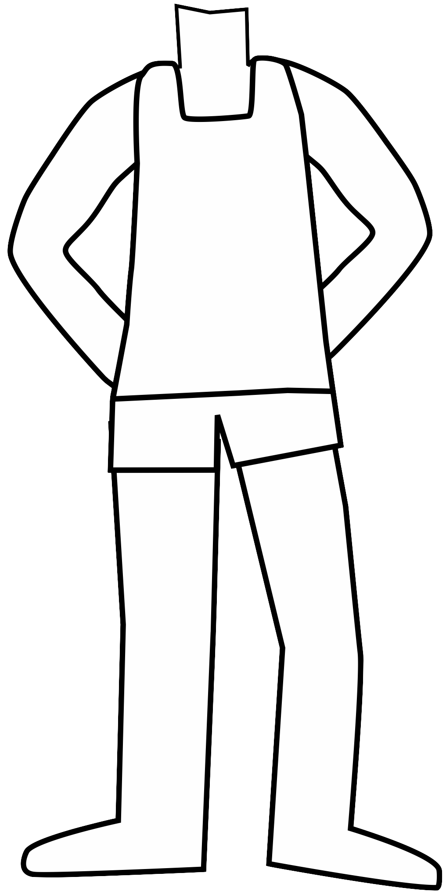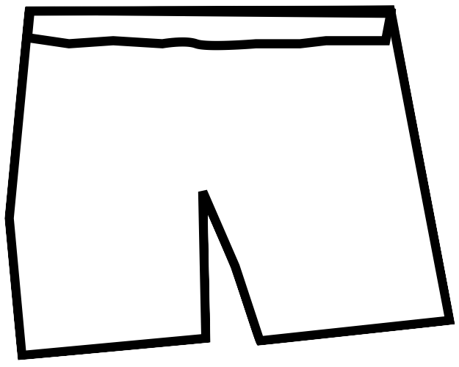

Length of hair

Width of smile

Nose

–

bridge

to tip

Eye

-

corner to

corner

Shoulder to

shoulder

Elbow to finger

Elbow to wrist

Hip to knee

Knee to ankle

Hip to ankle

Hip to hip

Ankle to toe

Heel to toe

**Description:**

Metric Me is a measurement activity where students measure their body

parts in metric units and record the measurements.

**Skills:**

The students will measure lengths in standard units of meters and centimeters.

**Grade levels:**

2

-

5

**Background information:**

Before completing the activity, students need to have a ba-

sic knowledge of metric units of length. This activity is designed as a review activity for

students who already have a basic understanding of metric measurement.

**Materials:**

Metric Me worksheet

Meter sticks

pencils

**Procedure:**

1.

Introduce the activity to students by explaining that they have all just qualified as

athletes in the 2012 Olympics. Tell them they now need to report their “stats” to the

Olympic committee.

2.

Read over the worksheet and make sure students understand what they should

measure on the worksheet. Demonstrate as necessary.

3.

Allow students to work on measuring body parts and recording.

4.

Assess the students by checking for reasonable answers. Answers will vary.

**Extending the activity:**

This could be an introductory activity to a complete

[s](http://www.teacherspayteachers.com/Product/Math-Olympic-Games-for-Kids)

[classroom measurement Olympic](http://www.teacherspayteachers.com/Product/Math-Olympic-Games-for-Kids)

[.](http://www.teacherspayteachers.com/Product/Math-Olympic-Games-for-Kids)

You can purchase a pre

-

made classroom Olympics in my teachers pay teachers store.

This includes a teachers guide, printable signs, directions for games, recording sheets,

medals, and a certificate of completion.



Thank you for downloading this product. I

hope you enjoy the activities included.

You can find more teaching resources on

my blog:

[!](http://readysetread2me.blogspot.com)

[Ready. Set. Read](http://readysetread2me.blogspot.com)

readysetread

2

2

me.blogspot.com

Please check out my

[s](http://www.teacherspayteachers.com/Store/Jackie-Higgins)

[Teachers pay Teacher](http://www.teacherspayteachers.com/Store/Jackie-Higgins)

Store!

I’d love if you rate my printable and follow for more teaching

resources.