Heat Part II
Objective: Students will develop a hypothesis and communicate the steps and results from an investigation in written reports and oral presentations. This relates to
MS-ESS2-2. | Construct an explanation based on evidence for how geoscience processes have changed Earth's surface at varying time and spatial scales. [Clarification Statement: Emphasis is on how processes change Earth’s surface at time and spatial scales that can be large (such as slow plate motions or the uplift of large mountain ranges) or small (such as rapid landslides or microscopic geochemical reactions), and how many geoscience processes (such as earthquakes, volcanoes, and meteor impacts) usually behave gradually but are punctuated by catastrophic events. Examples of geoscience processes include surface weathering and deposition by the movements of water, ice, and wind. Emphasis is on geoscience processes that shape local geographic features, where appropriate.]

.
Docent Lab Guidelines:
- Schedule a date and time with your teacher to have the students come into the lab. Allow at least 45minutes of class time. Ideally it would be better if you can get 1hr. min.
- Input the day and time into the Science Lab Master Schedule. Please make sure you add set up and clean up time to the class time.
- Allow 30 minutes to set up and 30 minutes of clean up time.
_____________________________________________________________________________________
General Docent Information about the Subject Matter – For Reference
Convection

HOW IT WORKS

Introduction to Convection
Some concepts and phenomena cross disciplinary boundaries within the earth sciences, an example being the physical process of convection. It is of equal relevance to scientists working in the geologic, atmospheric, and hydrologic sciences, or the realms of study concerned with the geosphere, atmosphere, and hydrosphere, respectively. The only major component of the earth system not directly affected by convection is the biosphere, but given the high degree of interconnection between different subsystems, convection indirectly affects the biosphere in the air, waters, and solid earth.
Convection can be defined as vertical circulation that results from differences in density ultimately brought about by differences in temperature, and it involves the transfer of heat through the motion of hot fluid from one place to another. In the physical sciences, the term fluid refers to any substance that flows and therefore has no definite shape. This usually means liquids and gases, but in the earth sciences it can refer even to slow-flowing solids. Over the great expanses of time studied by earth scientists, the net flow of solids in certain circumstances (for example, ice in glaciers) can be substantial.

Convection and Heat
As indicated in the preceding paragraph, convection is related closely to heat and temperature and indirectly related to another phenomenon, thermal energy. What people normally call heat is actually thermal energy, or kinetic energy (the energy associated with movement) produced by molecules in motion relative to one another.
Heat, in its scientific meaning, is internal thermal energy that flows from one body of matter to another or from a system at a higher temperature to a system at a lower temperature. Temperature thus can be defined as a measure of the average molecular kinetic energy of a system. Temperature also governs the direction of internal energy flow between two systems. Two systems at the same temperature are said to be in a state of thermal equilibrium; when this occurs, there is no exchange of heat, and therefore heat exists only in transfer between two systems.
There is no such thing as cold, only the absence of heat. If heat exists only in transit between systems, it follows that the direction of heat flow must always be from a system at a higher temperature to a system at a lower temperature. (This fact is embodied in the second law of thermodynamics, which is discussed, along with other topics mentioned here, in Energy and Earth.) Heat transfer occurs through three means: conduction, convection, and radiation.

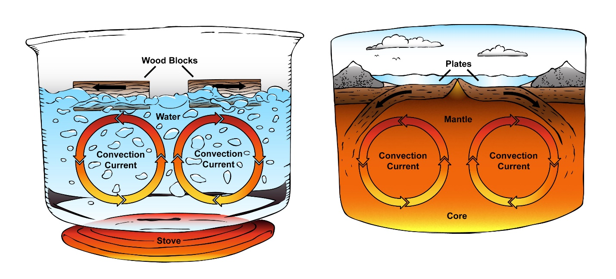
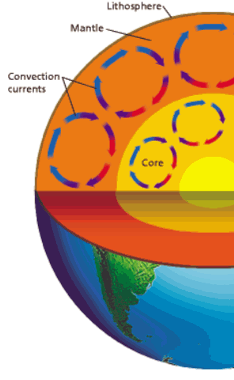

To make this work, Set up the jars for Experiment #3 ahead of time (one set per table) and have the students go straight to the tables to record the beginning temperatures and make predictions. Then the students go to the carpet to get directions for Experiment #1. After Experiment#1 at 30 minutes, students record the temperatures, then do Experiment #2. We then end the lab with the final reading and discussing the results.

Experiment #1 What can Convection currents do?

Materials: 2 glass jars, small piece of cardboard matches, ice, 2 plastic tubs, ice
Experiment is done in groups of 3.
Instructions: Place one jar in a plastic tub of ice. Place the other jar in a tub of warm water. Let sit for 10 minutes.
1 .Remove the jar from the tub of ice. A docent will light a match and immediately blow it out. 2. Hold the opening of the jar over the smoking match to trap the smoke. 3. Place the cardboard on the opening of the jar and turn the jar right side up. 4. Place the jar from the tub of warn water over the jar from the tub filled with ice. 5. Remove the cardboard, making sure to keep the jars together so the smoke cannot escape. 6. Observe the movement of the smoke and record your observations
Draw Conclusions: What did the smoke so when you first removed the cardboard? What happened to the smoke when you flipped the jars over? What do you think the smoke would do if you placed the model in a hot-water bath? Try it.

Energy: Thermal

MS.Energy
Students who demonstrate understanding can:
MS-PS3-1. | Construct and interpret graphical displays of data to describe the relationships of kinetic energy to the mass of an object and to the speed of an object. [Clarification Statement: Emphasis is on descriptive relationships between kinetic energy and mass separately from kinetic energy and speed. Examples could include riding a bicycle at different speeds, rolling different sizes of rocks downhill, and getting hit by a wiffle ball versus a tennis ball.]
MS-PS3-2. | Develop a model to describe that when the arrangement of objects interacting at a distance changes, different amounts of potential energy are stored in the system. [Clarification Statement: Emphasis is on relative amounts of potential energy, not on calculations of potential energy. Examples of objects within systems interacting at varying distances could include: the Earth and either a roller coaster cart at varying positions on a hill or objects at varying heights on shelves, changing the direction/orientation of a magnet, and a balloon with static electrical charge being brought closer to a classmate’s hair. Examples of models could include representations, diagrams, pictures, and written descriptions of systems.] [Assessment Boundary: Assessment is limited to two objects and electric, magnetic, and gravitational interactions.]
MS-PS3-3. | Apply scientific principles to design, construct, and test a device that either minimizes or maximizes thermal energy transfer.* [Clarification Statement: Examples of devices could include an insulated box, a solar cooker, and a Styrofoam cup.] [Assessment Boundary: Assessment does not include calculating the total amount of thermal energy transferred.]
MS-PS3-4. | Plan an investigation to determine the relationships among the energy transferred, the type of matter, the mass, and the change in the average kinetic energy of the particles as measured by the temperature of the sample. [Clarification Statement: Examples of experiments could include comparing final water temperatures after different masses of ice melted in the same volume of water with the same initial temperature, the temperature change of samples of different materials with the same mass as they cool or heat in the environment, or the same material with different masses when a specific amount of energy is added.] [Assessment Boundary: Assessment does not include calculating the total amount of thermal energy transferred.]

Experiment #2
What material best heats water?
To be done in groups of 3
Materials per group: 3 medium size glass jars, black construction paper, white paper, aluminum foil, tape, 3 thermometers, paper for recording temperatures and predictions.

Predict: which material-white paper, black construction paper or aluminum foil most quickly raise the temperature of water when placed in direct sunlight or under a sunlamp?
Instructions: 1. Fill three jars with the same amount of water. 2. Wrap one of the materials around each jar, securing each with a piece of tape. 3. Place the jars on a level surface that is in direct sunlight or under a heat lamp. 4. Place a thermometer in each jar, stir the water and record the temperature of the water in each jar. 5. Wait 30 minutes, stir the water and record the temperature of the water in each jar again.

Further exploration: Set the jars in a place that does not receive direct sunlight. Which jar will lose the most heat? Wait 30 minutes, stir the water, and record the temperature. Which jar lost the most heat?

Experiment #3
Distance and Energy
Question: What happens to the light beam from a flashlight as you move the flashlight farther from a piece of paper?
Materials: graph paper, flashlights, pencils, metric rulers
To be done in groups of 3
Instructions: Step 1: Tape a sheet of graph paper to the wall and write an X in the middle of the paper. Step 2: Hold a flashlight 2 cm away from the paper. Turn on the flashlight and keep the X in the middle of the beam. Trace a circle around the spot of light. Count and record on the graph paper the number of squares inside the circle. Step 3: Predict what will happen to the size of the circle if you move the flashlight to 4 cm and then to 8 cm from the paper? How will this affect the brightness of the light and the size of the circle? Why? Step 4: Check your predictions by moving the flashlight 4 and 8 cm from the paper.
Infer: How does the distance from the light source affect the amount of energy each square receives?
Infer: If a planet were twice as far from the sun as Earth is, would it receive half as much energy from the Sun as Earth does? Explain. What effect would this have on the planet’s temperature?

