How Does Heat Move in Liquids and Gases
Objective: Students will develop a hypothesis and communicate the steps and results from an investigation in written reports and oral presentations. This relates to
MS-ESS2-2. | Construct an explanation based on evidence for how geoscience processes have changed Earth's surface at varying time and spatial scales. [Clarification Statement: Emphasis is on how processes change Earth’s surface at time and spatial scales that can be large (such as slow plate motions or the uplift of large mountain ranges) or small (such as rapid landslides or microscopic geochemical reactions), and how many geoscience processes (such as earthquakes, volcanoes, and meteor impacts) usually behave gradually but are punctuated by catastrophic events. Examples of geoscience processes include surface weathering and deposition by the movements of water, ice, and wind. Emphasis is on geoscience processes that shape local geographic features, where appropriate.]

.
Docent Lab Guidelines:
- Schedule a date and time with your teacher to have the students come into the lab. Allow at least 25 minutes of class time. -
- Input the day and time into the Science Lab Master Schedule. Please make sure you add set up and clean up time to the class time.
- Allow 30 minutes to set up and 30 minutes of clean up time.
_____________________________________________________________________________________
General Docent Information about the Subject Matter – For Reference
Convection

HOW IT WORKS

Introduction to Convection
Some concepts and phenomena cross disciplinary boundaries within the earth sciences, an example being the physical process of convection. It is of equal relevance to scientists working in the geologic, atmospheric, and hydrologic sciences, or the realms of study concerned with the geosphere, atmosphere, and hydrosphere, respectively. The only major component of the earth system not directly affected by convection is the biosphere, but given the high degree of interconnection between different subsystems, convection indirectly affects the biosphere in the air, waters, and solid earth.
Convection can be defined as vertical circulation that results from differences in density ultimately brought about by differences in temperature, and it involves the transfer of heat through the motion of hot fluid from one place to another. In the physical sciences, the term fluid refers to any substance that flows and therefore has no definite shape. This usually means liquids and gases, but in the earth sciences it can refer even to slow-flowing solids. Over the great expanses of time studied by earth scientists, the net flow of solids in certain circumstances (for example, ice in glaciers) can be substantial.

Convection and Heat
As indicated in the preceding paragraph, convection is related closely to heat and temperature and indirectly related to another phenomenon, thermal energy. What people normally call heatis actually thermal energy, or kinetic energy (the energy associated with movement) produced by molecules in motion relative to one another.
Heat, in its scientific meaning, is internal thermal energy that flows from one body of matter to another or from a system at a higher temperature to a system at a lower temperature. Temperature thus can be defined as a measure of the average molecular kinetic energy of a system. Temperature also governs the direction of internal energy flow between two systems. Two systems at the same temperature are said to be in a state of thermal equilibrium; when this occurs, there is no exchange of heat, and therefore heat exists only in transfer between two systems.
There is no such thing as cold, only the absence of heat. If heat exists only in transit between systems, it follows that the direction of heat flow must always be from a system at a higher temperature to a system at a lower temperature. (This fact is embodied in the second law of thermodynamics, which is discussed, along with other topics mentioned here, in Energy and Earth.) Heat transfer occurs through three means: conduction, convection, and radiation.

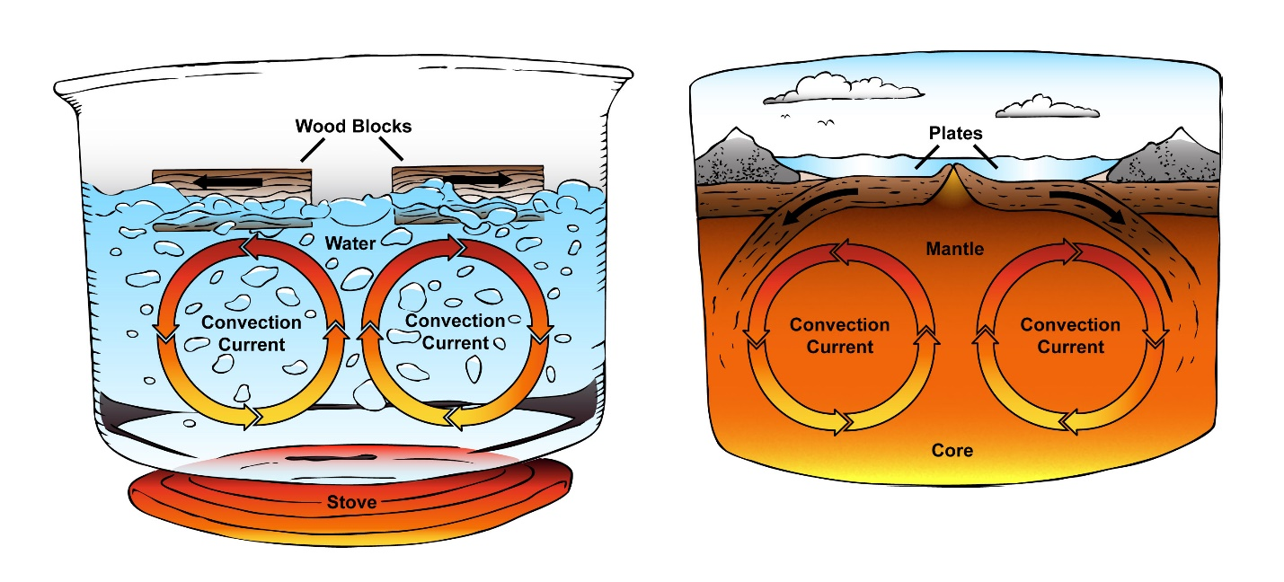
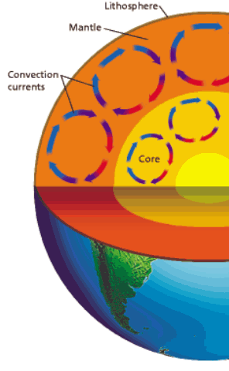

Experiment
Experiment #1: How does heat move in liquids and gases:
Estimated time: 15-20 minutes
Materials Needed:
- Clear plastic container
- Ice cube dyed with blue food coloring
- Red food coloring
- Color pencils
- paper
Preparation:
- Before class starts dye water blue and freeze it into ice cubes

Docent Led discussion:
When an ice cube melts in room temperature water, what do you think happens to the melted water? Write your answer as a prediction in the form “If an ice cube melts in room-temperature water…”
Test your prediction
Instructions:
- Fill the plastic container about two-thirds full of water. The water should be at room temperature and perfectly still. Gently place the blue ice cube in the water at one end of the container. Add two drops of red food coloring to the water at the opposite end of the container.
- Observe Carefully observe where the blue water flows and where the red water flows. Use color pencils to draw the flows of the two different-color waters.
Draw Conclusions
- Analyze How would you explain what you observed?
- Did your observations support your prediction? What caused the behavior of the blue water? Why did the water in the plastic container appear to circulate? What happens when warm and cool water meet? Explain your answer

