***1st Grade – Sound Waves***

|  |  |  |
| --- | --- | --- |
| |  | | --- | | **1-PS4-1. Plan and conduct investigations to provide evidence that vibrating materials can make sound and that sound can make materials vibrate.** | |  |

**Docent Scheduling Guidelines:**

1. Schedule a date and time with your teacher to have the students come into the lab. Schedule a minimum of 1 hour of classroom time.
2. Docent(s) should plan to arrive early to set up before the class arrives.
3. Input the day and time into the Science Lab Master Schedule. Please make sure you add set up and clean up time to the overall class time.
4. Give a brief 10 minute discussion on sounds waves. You can also opt to play a short video on the science of sound. There are several video options listed below.
5. The experiment(s) will be to make musical instruments. The main goal/challenge is for the students to try and come up with make a high pitch and a low pitch instrument. They can make as many instruments as they want during your time period. You can give them the option of making the instructions listed below or coming up with their own based on the available materials.
6. Review the last 5-10 minutes of class. Ask the students if they would like to come up to the front of the class and share their instruments and / or observations.

**Tips:**

* This lab session works best with one docent per table group. If there is not enough docents than limit the number of instruments the students can make.
* Make a sample of each instrument the students will make that day.
* Students will need help stretching the balloon on the tin cans for the drums.

**Sound Waves: For Docent’s Reference Only**

**What are sound waves?**

Like [light](http://quatr.us/physics/light), sound travels through the air in waves, but unlike light, sound is not made of lots of tiny [particles](http://quatr.us/physics/light/photon.htm). When something makes a sound, like [you](http://quatr.us/biology/animals/chordates/mammals/humans.htm) clapping your hands, it's because when you clapped your hands that shook the air [molecules](http://quatr.us/chemistry/atoms/molecules.htm) around your hands and made them vibrate (that means they shake quickly back and forth). This vibration, in turn, shook the [air molecules](http://quatr.us/physics/weather/atmosphere.htm) a little further away from your hands, and they shook the air molecules next to them, and so on, until the air molecules inside your [ear](http://quatr.us/biology/animals/nervous/ears.htm) were vibrating too (and inside the ears of the people sitting near you too).

When the air molecules inside your ear begin to shake, they wobble tiny hairs inside your ear that are connected to [nerves](http://quatr.us/biology/animals/nervous/neuron.htm) under your skin. If your ears are working, these nerves then send messages to your [brain](http://quatr.us/biology/animals/nervous/brain.htm) to tell you that you heard a noise.

Because sound has to move [molecules](http://quatr.us/chemistry/atoms/molecules.htm) in order to travel, it's impossible for sound to move through [space](http://quatr.us/physics/space), where there are very few molecules. Space is a very quiet place. But sound doesn't have to move through air - it can just as easily move through [water](http://quatr.us/chemistry/atoms/water.htm), or through [metal wires](http://quatr.us/chemistry/metals). In fact, sound moves faster through water than it does through [air](http://quatr.us/physics/weather/atmosphere.htm).

But whether in air or in water, sound moves much more slowly than [light](http://quatr.us/physics/light) does. While light travels at 186,000 miles per second, sound only goes 0.2 miles per second (343 meters per second, or about 770 miles per hour). A fast airplane can go faster than the speed of sound. Because of this, you often hear things long after you saw them. For instance, you have to wait several seconds to hear the [thunder](http://quatr.us/physics/weather/lightning.htm) after you see the lightning in a storm, even though they are the same thing.

**Videos Options on Sound Waves:**

* 1. What is Sound? By SciShow Kids (run time 3 min. 57 sec)

<https://www.youtube.com/watch?v=3-xKZKxXuu0>

* 1. Sound (run time 2 min. 50 sec.)

<http://ca.pbslearningmedia.org/resource/ba1c1421-6d54-4044-98b7-496f325cccb7/sound/>

* 1. Science of Sound (run time 5 min. 8 sec.) <http://www.bing.com/videos/search?q=what+is+sound+for+kids&FORM=HDRSC3#view=detail&mid=1BE927444B41459D6CBD1BE927444B41459D6CBD>
  2. Sound Excerpt from Bill Nye (run time 1 min. 20 sec.)

<https://www.youtube.com/watch?v=ACeUO4ufx2I>

**Demonstration: Tuning Fork**

**Estimated Time: 3 minutes**

Docents can use the tuning fork during their discussion to demonstration sound vibrations. All you will need is a large breaker or bowl of water and the tuning fork. Simple hit the tuning fork on the table and slowing insert the tuning fork into the water.

[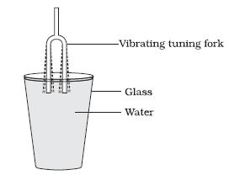](http://www.google.com/url?sa=i&rct=j&q=&esrc=s&source=images&cd=&cad=rja&uact=8&ved=0ahUKEwjI5Kb6tbjLAhVBWWMKHfNUAPkQjRwIBw&url=http://www.ekshiksha.org.in/eContent-Show.do?documentId%3D68&psig=AFQjCNEUAP5WMYiOuz1BE6ZdECZwn2adDg&ust=1457778378990969)

**Experiment: Making Instruments**

***Estimated time: 45 minutes***

Students will make at least two instruments, more if there are more docents available. The challenge is to make at least one high pitch instrument and one low pitch instrument. Docents have the flexibility of deciding how they want to coordinate the activities. For example you can preselect only 2 different instruments to make. Or if there are 5 docents then there could be 5 tables each with a different instrument. Students could then rotate to which ever table interest them. Also there could be a table with various materials and let students try to make their own type of instrument. Also docents can contact the teacher a week before class and encourage students to bring in recycled materials (for example empty Kleenex boxes can make a great guitar).

**Sound Sandwich**

*(From the Exploratorium)*

**Materials:**

* Large Popsicle / craft sticks
* Straws
* Large (wide) Rubber Bands
* Small (thin) rubber bands
* Scissors
* Markers – to write name on harmonica

**Instructions:**

1. Stretch a wide rubber band lengthwise over one of the craft sticks.
2. Cut two small pieces of straw, each about 1 inch to 1 1⁄2 inches (2.5 to 3.8 cm) in length. Put one of the small straw pieces under the wide rubber band, about a third of the way up from one end of the stick. Put the other piece of straw on top of the rubber band, about a third of the way from the other end of the stick
3. Take the second craft stick and place it on top of the first one.
4. Wrap one of the smaller rubber bands a few times around the end of the stick where you placed the second piece of straw, about 1/2 inch from the end. Make sure the rubber band pinches the two sticks tightly together.
5. Wrap the second small rubber band around the other end of the stick, about 1/2 inch from the end. When you’re done, both ends should be pinched together and there should be a small space between the two craft sticks, created by the pieces of straw.   
   [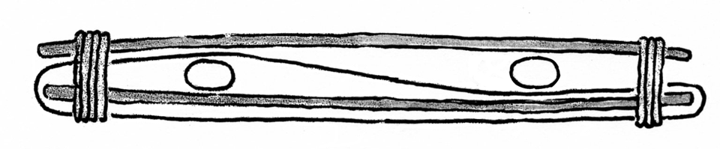](http://www.exploratorium.edu/sites/default/files/soundsandwich.gif)

**To Do and Notice**

When your harmonica is complete, just put your mouth in the middle and blow! (Remember to blow through the sticks, not the straws.) Notice that you can make different sounds by blowing through different areas of the instrument, blowing harder / softer, slightly biting down on the stick or by moving the straws closer together or farther apart. Experiment to find out how many different sounds the Sound Sandwich will make.

**What’s Going On?**

When you blow into the Sound Sandwich, you make the large rubber band vibrate, and that vibration produces sound. Long, massive objects vibrate slowly and produce low-pitched sounds; shorter, less-massive objects vibrate quickly and produce high-pitched sounds. The tension of a rubber band also will change its pitch: Higher tensions lead to higher-pitched resonances. When you move the straws closer together, you shorten the part of the rubber band that can vibrate, so the pitch gets higher than the original sound. You may also have played with this effect if you’ve ever stretched a blade of grass between your fingers and blown into the gap to make the grass vibrate and buzz.

**How to Video: Good for Docents to watch before class starts**

<http://www.exploratorium.edu/afterschool/activities/index.php?activity=137&program=591>

*(From the Exploratorium)*

|  |  |  |  |  |
| --- | --- | --- | --- | --- |
| Secret Bells   |  | | --- | | 15 Minutes What Do I Need? |  |  | | --- | | * scissors * string * wire hanger * table (or a wall, or a door) * metal spoon | | http://www.exploratorium.edu/science_explorer/secret_bells/kidneardoor.gif   |  | | --- | |  | |
|  |  |

|  |  |  |
| --- | --- | --- |
| What Do I Do? 1With your scissors, cut a piece of string about 3 feet long. (Grown-ups should cut a piece about 4 feet long.)    2Hold the two ends of the string in one hand. The rest of the string will make a loop.  http://www.exploratorium.edu/science_explorer/secret_bells/hands_string.gif | |  | | --- | | String and hanger |   3Lay the loop over the hook part of the hanger. Push the two ends through the loop, and pull them all the way through the other side. (This is easier to undo than a knot.) |

|  |  |  |  |
| --- | --- | --- | --- |
| 4 Wrap the loose ends of the string two or three times around the first fingers on each hand.   |  | | --- | | http://www.exploratorium.edu/science_explorer/secret_bells/kid1.gif |   5Swing the hanger so it gently bumps against the leg of a table, or against a door. What did it sound like? Probably not much. 6Now put your hands over the openings of your ears. (Don't put your fingers in your ears!) Hold your hands tight to the sides of your head. Lean over and gently bump the hanger again. | |  | | --- | | http://www.exploratorium.edu/science_explorer/secret_bells/kidneardoor.gif |   7Wow! Now what does it sound like? Church bells? Chimes?  8Want to hear what a spoon sounds like? Unwrap your fingers, then pull on the loop end of the string. The whole string will come off the hanger, and you can reloop it around the spoon.    Try this with other things from your kitchen. |

**What’s Going On?**

Although most of the sounds we hear are transmitted through the air, air is not the only carrier of sound waves—nor is it the best. A ticking clock can be heard through the air if you’re close enough, but put your ear to the table with the clock on it and the ticking will sound much louder.

When something vibrates, the strength of the vibration and the length of time the vibrations continue can vary quite a bit, depending on the materials involved. Hit a piece of wood with a stick and the sound lasts for just an instant. Hit a metal gong with the same stick, and the sound may continue for many seconds. Water is another good transmitter of sound. Put your ear into a pan of water and listen to two rocks clacking together.

Why the difference? In some materials, the molecules are tightly packed together; in other materials, the molecules are more loosely arranged. How close the molecules are to one another can affect how easily they can bump into each other to start a vibration moving along.

**Paper Towel Roll Kazoo**

[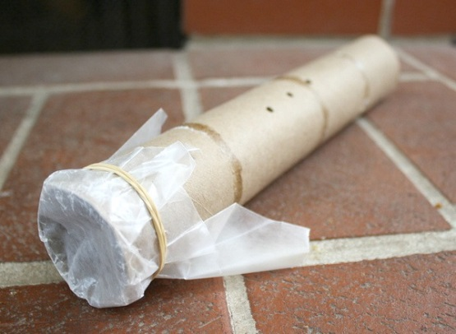](http://cdn2.buggyandbuddy.com/wp-content/uploads/2013/03/b.jpg)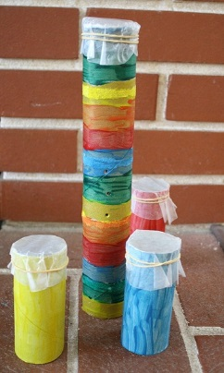

**Materials**

* Cardboard tube (toilet paper roll or paper towel roll)
* [Wax paper](http://www.amazon.com/gp/product/B0036QO8M6/ref=as_li_ss_tl?ie=UTF8&camp=1789&creative=390957&creativeASIN=B0036QO8M6&linkCode=as2&tag=buggyandbuddy-20)
* Rubber bands
* Sharp pencil or skewer (or other sharp object) to poke holes
* Markers to decorate your kazoo (optional)

**Directions**

Cover the end of your cardboard tube with [wax paper](http://www.amazon.com/gp/product/B0036QO8M6/ref=as_li_ss_tl?ie=UTF8&camp=1789&creative=390957&creativeASIN=B0036QO8M6&linkCode=as2&tag=buggyandbuddy-20). Secure it with a rubber band.

1. Poke a hole in the side of the tube using the sharp pencil or other sharp object. Docents to assist with this step.
2. Decorate the tube using markers and put your name on it.
3. Cover one end of the tube with wax paper. Secure with a rubber band.
4. Put the open end of the tube up to your mouth and hum or say “do” over and over and to make the kazoo sound. It takes a little practice.
5. Do different size tube produce different sounds?
6. Do the number of holes in the tube effect the sound?

**How to Video: Good for Docents to watch before class starts**

<https://www.youtube.com/watch?v=1Y-T8cRpt94>

**Windpipe Straws**

**Materials**

* Straws
* Scotch Tape
* Scissors
* Labels – for students names

**Instructions:**

[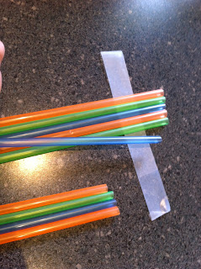](http://laughingkidslearn.com/wp-content/uploads/blogger/-xDUr4SF8sN0/UPNoOl_eMaI/AAAAAAAABL0/X-EU85OMlrU/s1600/IMG_4257.JPG)

* Simply lay out a line of sticky take with the sticky part facing UP.
* Lay each of the straws on the sticky tape.

[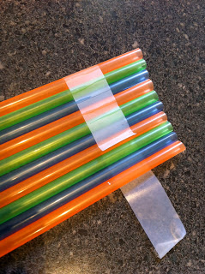](http://laughingkidslearn.com/wp-content/uploads/blogger/-lVg-FUzWBKE/UPNoQcwcs4I/AAAAAAAABME/bHXtFjJtd1Y/s1600/IMG_4258.JPG) [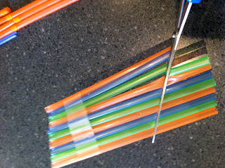](http://laughingkidslearn.com/wp-content/uploads/blogger/-6vjeoeFM4p4/UPNoOjQVrjI/AAAAAAAABL4/qKb4MjvQI2Y/s1600/IMG_4260.JPG)

* Fasten the straws with the tape.
* Cut one end of the straws on a diagonal. This will give the straws various lengths
* Children can clearly hear their breath change as it passes through each straw.
* Write your name on the label and place it on the flute.

[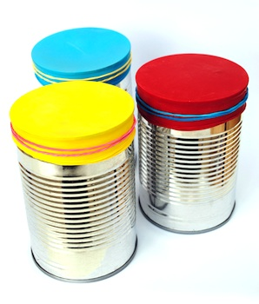](http://lwlink3.linkwithin.com/api/click?format=go&jsonp=vglnk_145772648975312&key=8a69ede45b8445f6b533712ba9899ffb&libId=ilo4ozf40100r7tw000DLdmjm3ks4&loc=http://www.thecraftycrow.net/earth-day/page/3/&v=1&out=http://belladia.typepad.com/.a/6a00d8341cc08553ef014e61127668970c-pi&ref=http://www.google.com/url?sa%3Di%26rct%3Dj%26q%3D%26esrc%3Ds%26source%3Dimages%26cd%3D%26ved%3D0ahUKEwiczIaTtrnLAhUTwWMKHXYLBW0QjxwIAw%26url%3Dhttp://www.thecraftycrow.net/earth-day/page/3/%26psig%3DAFQjCNHA5zOlltYB1zJFKBFt5UH5aBmq_Q%26ust%3D1457812798089692%26cad%3Drjt&title=Things%20to%20Make%20and%20Do,%20Crafts%20and%20Activities%20for%20Kids%20-%20The%20Crafty%20Crow:%20Earth%20Day%20Crafts&txt=)

**Tin Drums**

**Materials**

* Tin cans or coffee cans
* Large Balloons
* Scissors
* Large Rubber Bands
* Chop sticks or pencils

**Instructions:**

1. Cut the neck off a balloon. For durability 2 balloons works better but 1 also works.
2. With some docent help stretch the balloon over the open end of the can and secure with a rubber band.
3. Use chop sticks or pencils as drum sticks or hand and play.
4. Does the size of the can affect the sound produced? What happens if the balloon is not on tight?

[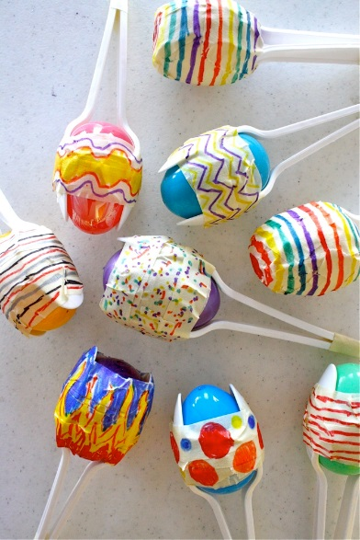](http://www.danamadeit.com/2012/04/tutorial-easter-egg-maracas-for-cinco-de-mayo.html/a8)

**Easter egg Maracas**

**Materials**

* Easter Eggs
* Plastic Spoons
* Beans or rice
* Masking Tape
* Markers for decorating

**Instructions:**

1. Fill an egg with beans or rice
2. Place two spoons between the egg and tape. Make sure tape goes all the way around the egg.
3. Tape the bottom ends of the spoons together
4. Decorate

**Early Finishers**

If there are students who finish early they are welcome to use the app on the IPad called Sound Uncovered. It is already loaded on all the IPads. Since the class room will be full of noise it would be best to ask the teacher if she can check out 3 headphones.

**Sound Uncovered Description**

Explore the surprising side of sound with Sound Uncovered, an interactive book featuring auditory illusions, acoustic phenomena, and other things that go bump, beep, boom, and vroom.