Grade TK - Weather
Objective:
Students will learn about weather, the water cycle and demonstrate how hurricanes and rain are formed.

ESS2.D: Weather and Climate
▪ Weather is the combination of sunlight, wind, snow or rain, and temperature in a particular region at a particular time. People measure these conditions to describe and record the weather and to notice patterns over time. (K-ESS2-1)

Docent Lab Guidelines:
- Schedule a date and time with your teacher to have the students come into the lab. Schedule a minimum of 1 hour of classroom time.
- Docent(s) should plan to arrive early to set up before the class arrives.
- Input the day and time into the Science Lab Master Schedule. Please make sure you add 30 minutes of set up time and at least 30 minutes of clean up time to the overall class time.
- Students are to wear lab aprons. Safety glasses are not required for this session.
- Have the students sit on the carpet at the start of class.
- Give a brief 5-10 minute discussion on weather. For this age group the discussion is very basic. You can also opt to play a short video(s) on Weather and the Water Cycle. There is a list of videos below.
- If there are not enough docent’s discuss with your teacher the possibility of having a few of your classroom’s Big Buddies there to help.
- Allow enough time at the end for students to wash up afterwards if needed. Girls can wash up in the adjacent girl’s restroom.
- The last 5-10 minutes of class review with the students their observations.

Weather Basics: For Docent’s Reference Only
The weather is all around us, all the time. It is an important part of our lives and one that we cannot control. Instead the weather often controls how and where we live, what we do, what we wear and what we eat. Someone who studies the weather is called a meteorologist. Weather predictions are made by forecasters who you see on television.
What causes weather?
Because the Earth is round and not flat, the Sun's rays don't fall evenly on the land and oceans. The Sun shines more directly near the equator bringing these areas more warmth. However, the Polar Regions are at such an angle to the Sun that they get little or no sunlight during the winter, causing colder temperatures. These differences in temperature create a restless movement of air and water in great swirling currents to distribute heat energy from the Sun across the planet. When air in one region is warmer than the surrounding air, it becomes less dense and begins to rise, drawing more air in underneath. Elsewhere, cooler denser air sinks, pushing air outward to flow along the surface and complete the cycle.
Why do mountains affect weather and climate?
There are two sides to a mountain: wayward and leeward. Whenever it is raining, the wayward side gets the rain. As a cloud goes up the mountain, it keeps raining until there is no more water in the cloud. Now, as the cloud starts to go down the other side of the mountain, there is no more precipitation. So, the leeward side of the mountain doesn't get any rain. The flat ground on this side of the mountain is dry and humid.
What is the Water Cycle?
Earth has a limited amount of water. So, that water keeps going around. We call it the water cycle. The water cycle begins with evaporation. Evaporation is when the sun heats up water in rivers, lakes or the ocean. Then turns it into water vapor or steam. The water vapor or steam leaves the body of water and goes into the air. Transpiration is the process by which plants lose water out of their leaves. Condensation is when water vapor in the air gets cold and changes back into water to form clouds. Think of it this way, when you open a cold soda on a hot summer day, your soda will start to sweat as water droplets form on the outside of the can. Precipitation occurs when so much water has condensed that the air can't hold it anymore. This is how we get rain or snow. Collection happens when the precipitation falls and is collected back in the oceans, lakes and rivers. When it falls to the ground, it will soak into the earth and become ground water. This is the water cycle and it just keeps repeating.
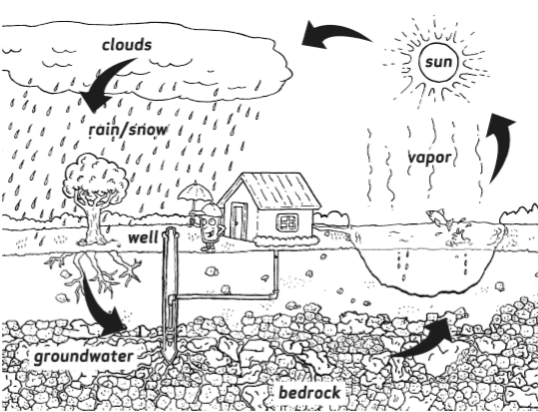
Why do we have seasons?
As the Earth spins on its axis, producing night and day, it also moves about the Sun in an elliptical (elongated circle) orbit that requires 365 1/4 days to complete. The Earth's axis is tilted at 23.5 degrees and is why we have seasons. When the Earth's axis points towards the Sun, it is summer for that hemisphere. When the Earth's axis points away, winter can be expected.
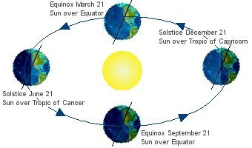
What is the significance of the Sun to the Earth?
Without the Sun, there would be no weather. Earth is positioned as the third planet, so our temperatures are sustainable for life. The average temperature of Mars is much colder, while Venus is much hotter.
How can you tell what time it is by looking at the Sun?
Because the sun ALWAYS rises in the east and sets in the west, you can tell the time just by looking at where the sun is. When you look east and the sun is on the horizon that means it’s approximately 6:00am. When the sun is directly above your head that means its noon. When you look to the west and the sun is on the horizon that means it’s approximately 6:00pm.
Why do we get more sunlight in the summer than in the winter?
You might not have noticed this, but the Earth tilts over slightly. In our summer, the North Pole is pointing towards the Sun so the Sun rises and sets roughly from due east to due west. In winter, the Earth is on the other side of the Sun so the North Pole is pointing away from the Sun. This means the Sun rises and sets more towards the southeast and southwest. You might notice this as you look out of the window. Think back to how high in the sky the sun was during the summer. Compare this to where the sun is during the winter and you'll see it's much lower down towards the horizon. Because the sun is lower down on the horizon, there's less time for it to travel between horizons. There's less distance for it to travel so the sun rises later and sets earlier meaning there's less daylight.
What is the purpose of the Moon?
The tidal effect of the moon helps to recirculate the oceans and keep them from becoming stagnated. The result of which would be catastrophic for advanced forms of life like humans.
Why do the leaves change color?
During the spring and summer the leaves have served as factories where most of the foods necessary for the tree's growth are manufactured. This food-making process takes place in the leaf in numerous cells containing chlorophyll, which gives the leaf its green color. Along with the green pigment are yellow to orange to red pigments as well. Most of the year these colors are masked by great amounts of green coloring. But in the fall, because of changes in the length of daylight and changes in temperature, the leaves stop their food-making process. The chlorophyll breaks down, the green color disappears, and the yellow to orange to red colors become visible and give the leaves part of their fall splendor. The best time to enjoy the autumn color would be on a clear, dry, and cool day.

Videos on Weather:
- Clouds and Weather: Everyday Learning (run time 2 min. 13 sec, KET educational video for kids) http://www.pbslearningmedia.org/resource/evscps.sci.life.clouds/clouds-and-weather/
- The Water Cycle: How clouds are formed (run time 2 min. 43 sec.) https://www.youtube.com/watch?v=s0bS-SBAgJI
- Dinosaur Discoveries: Hurricanes | Dinosaur Train (run time: 1 min. 26 sec.)
http://www.pbslearningmedia.org/resource/4346af41-eb81-4af8-bc2d-428b5fb9a121/4346af41-eb81-4af8-bc2d-428b5fb9a121/
- Dinosaur Discoveries: Water Cycle (run time: 1 min. 26 sec.) http://www.pbslearningmedia.org/resource/db190709-5b02-4bd9-aa80-340bf16e764c/db190709-5b02-4bd9-aa80-340bf16e764c/
- Earth System: El Nino’s Influence on Hurricane Formation (run time: 1 min. 17 sec.) http://www.pbslearningmedia.org/resource/ess05.sci.ess.watcyc.eshurricane/earth-system-el-nintildeos-influence-on-hurricane-formation/
Books To Read to the Class:
- Magic School Bus: Inside a Hurricane by Joanna Cole & Bruce Degen
- Shapes in the Sky by Josepha Sherman
- The Magic school Bus Wet All Over: The Water Cycle by Joanna Cole & Bruce Degen
Experiment #1: Making Rain (kid safe version)
Estimated hands-on time: 5-10 minutes
Students will work in groups of 2-3
Materials:
- 2 liter soda bottles with cap
- Warm water
- Blue food coloring
- spoons
- Ice cubes
- Large white rectangular bin (used to dispose of colored water)
- Paper towels

Preparation:
- Prior to the class arriving cut the soda bottle in half.
- Warm water in the microwave and set aside in kid friendly size pitchers or pourable measuring cups.
- Place a roll of paper towels on the table and put a trash can nearby.
- Before the students begin the experiment engage them in a short discussion about how rain is formed. Feel free to use water cycle diagram attached.
Instructions:
- Pour 1-2 inches of water in the bottom half of the soda bottle.
- Add 1-2 drops of food coloring and stir with a spoon.
- Take the top half of the soda bottle making sure the cap is no and invert it into the bottom. The capped side of the bottle will be facing down.
- Fill the top with ice cubes.
- Observe what happens after several minutes.
- After a few minutes clouds will form and droplets of rain will form on the inverted bottle.
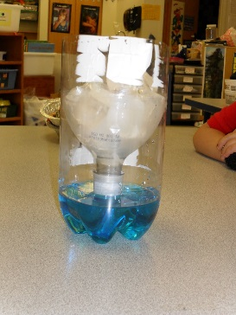
Clean-Up:
After groups have completed their experiments have them pour the water into the large white bin. This will allow for quicker clean-up between rotations. After the class is over the water can be poured down the drain or used to water the grass outside the lab.
Experiment #2: Hurricane in a Bottle (from Steve Spangler Science)
Estimated hands-on time: 5 minutes
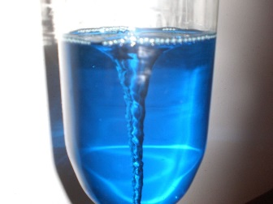
Materials:
- 2 liter soda bottles
- Water
- Food coloring
- Glitter & funnel (optional)
- Large white rectangular bin (used to dispose of colored water)
- Paper towels
- Tornado tubes

Preparation:
- Prior to the class set out empty 2 liter soda bottle at the table where this still will take place.
- Place a roll of paper towels on the table and put a trash can nearby.
- Place tornado tubes on the table.
- Before the students begin the experiment engage them in a short discussion about how hurricanes are formed.
Instructions:
- Add glitter (optional) to an empty bottle using a funnel.
- Fill the same glitter filled soda bottle with water. Use a large pitcher to completely fill the bottles.
- Add food coloring.
- Attach the Tornado tube to the top of the bottle full of water.
- Attach another soda bottle of the same size to the other end of the Tornado tube.
- Vigorously shake the bottles and turn the upside down.
- See if it makes a difference if the water is swirled as it falls into the bottom bottle.
- Does the bottle empty faster than if you were to just let it flow through the Tornado Tube without swirling the bottles.
How does it work? (Docent information)
Swirling the water in the bottle while pouring it out causes the formation of a vortex. The vortex looks like a tornado in the bottle. The formation of the vortex makes it easier for air to come into the bottle and allows the water to pour out faster. If you look carefully, you will be able to see the hole in the middle of the vortex that allows the air to come up inside the bottle. If you do not swirl the water and just allow it to flow out on its own, then the air and water have to essentially take turns passing through the mouth of the bottle.

What is a hurricane? (Docent information)
- Hurricane are tropical storms.
- They take place between the Equator and the Tropic of Cancer to the north, or between the Equator and the Tropic of Capricorn to the South. (Feel free to use the globe as a prop.)
- Hurricanes form at sea and cause dangerous, stormy seas.
- Some hurricanes reach the land and can destroy buildings and trees.
- A hurricane can blow high waves onto the land and cause flooding.
- The winds in a hurricane do not blow from west to east or north to south. They blow round in a circle.
- A hurricane is like a spinning top. The winds in a hurricane blow in a circle.
- North of the equator the winds in a hurricane blow in an anticlockwise direction.
- South of the equator the winds blow in a clockwise direction.
- The winds in a hurricane blow at a speed of at least 74 miles an hour. Their speed is often much more than this.
- Hurricanes form a thick mass of swirling clouds which can be seen from space.
- A hurricane can be six miles high and 400 miles wide. An area of calmer weather lies in the center of the hurricane. This is called the “eye of the storm”.
How do hurricanes form?
Hurricanes only form over really warm ocean water of 80°F or warmer. The atmosphere (the air) must cool off very quickly the higher you go. Also, the wind must be blowing in the same direction and at the same speed to force air upward from the ocean surface. Winds flow outward above the storm allowing the air below to rise. You can use the provided diagram.
Why does a hurricane move in circles? (Docent information)
- Hurricanes form their circular, swirling movement because of the spinning of the earth on its axis.
- If the earth did not spin, we would have very strong winds from the tropics to the poles and back.
- Because the earth spins, the spinning movement causes the wind to go to the right. Try this yourself. If you keep turning to the right, you will go round in a circle.
- The force that makes the wind turn to the right is called the Coriolis force.
- The Coriolis force does not affect winds above the Equator.
- Hurricanes never form on the Equator itself.

Experiment #3: Pet Cloud Activity
Estimated hands-on time: 10 minutes

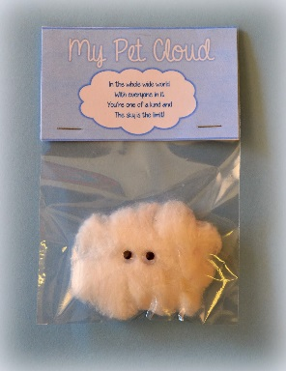

Materials:
- Jumbo Cotton balls (real cotton)
- Goggly Eyes
- School Glue
- Tent tags, printed on card stock
- Clear Treat bags
- Stapler
- Markers (to write names)
- Small pompoms (optional)
- Cloud diagram

Preparation:
- Cut out pre-printed tags. Make sure there is enough for each student.
- Fold in half to create a tent shape.
- Place glue, bowls of googly eyes and pompoms at the table where this station will take place.
- Set out markers and stapler.
- Before the students start on their project engage them in a short discussion about clouds. Some questions to ask are: What are clouds? What shapes can they be? How are clouds formed?
- Feel free to use the attached diagrams (1) How are clouds formed & (2) Types of Clouds.
What are clouds?
A cloud is a large collection of very tiny droplets of water or ice crystals. The droplets are so small and light that they can float in the air.
How are clouds formed?
All air contains water, but near the ground it is usually in the form of an invisible gas called water vapor. When warm air rises, it expands and cools. Cool air can't hold as much water vapor as warm air, so some of the vapor condenses onto tiny pieces of dust that are floating in the air and forms a tiny droplet around each dust particle. When billions of these droplets come together they become a visible cloud.
List of typical cloud formations: (For Docent Reference)
Cirrus clouds are the most common of the high clouds. They are composed of ice and are thin, wispy clouds blown in high winds into long streamers. Cirrus clouds are usually white and predict fair to pleasant weather. By watching the movement of cirrus clouds you can tell from which direction weather is approaching. When you see cirrus clouds, it usually indicates that a change in the weather will occur within 24 hours.
Cirrostratus clouds are thin, sheet like high clouds that often cover the entire sky. They are so thin that the sun and moon can be seen through them. Cirrostratus clouds usually come 12-24 hours before a rain or snow storm.
Cirrocumulus clouds appear as small, rounded white puffs that appear in long rows. The small ripples in the cirrocumulus clouds sometime resemble the scales of a fish. Cirrocumulus clouds are usually seen in the winter and indicate fair, but cold weather. In tropical regions, they may indicate an approaching hurricane.
"Alto" Clouds
Altostratus clouds are gray or blue-gray mid-level clouds composed of ice crystals and water droplets. The clouds usually cover the entire sky. In the thinner areas of the clouds, the sun may be dimly visible as a round disk. Altostratus clouds often form ahead of storms with continuous rain or snow.
Altocumulus clouds are mid-level clouds that are made of water droplets and appear as gray puffy masses. They usually form in groups. If you see altocumulus clouds on a warm, sticky morning, be prepared to see thunderstorms late in the afternoon.
Stratus Clouds
Stratus clouds are uniform grayish clouds that often cover the entire sky. They resemble fog that doesn't reach the ground. Light mist or drizzle sometimes falls out of these clouds.
Stratocumulus clouds are low, puffy and gray. Most form in rows with blue sky visible in between them. Rain rarely occurs with stratocumulus clouds, however, they can turn into nimbostratus clouds.
Nimbostratus clouds form a dark gray, wet looking cloudy layer associated with continuously falling rain or snow. They often produce precipitation that is usually light to moderate.
Cumulus clouds are white, puffy clouds that look like pieces of floating cotton. Cumulus clouds are often called "fair-weather clouds". The base of each cloud is flat and the top of each cloud has rounded towers. When the top of the cumulus clouds resemble the head of a cauliflower, it is called cumulus congestus or towering cumulus. These clouds grow upward and they can develop into giant cumulonimbus clouds, which are thunderstorm clouds.
Cumulonimbus clouds are thunderstorm clouds. High winds can flatten the top of the cloud into an anvil-like shape. Cumulonimbus clouds are associated with heavy rain, snow, hail, lightning and even tornadoes. The anvil usually points in the direction the storm is moving.

Pet Cloud Instructions:
- Stretch out cotton balls to create a cloud-like shape.
- Attach googly eyes with glue. Press in place and let glue dry.
- Use a single pompom to create a nose, if desired. Attach with glue.
- Place cloud in treat bag and attach printed tent tag.
- Docent to help student write student’s name on the tag.
- Student to take home their pet cloud.

